

# Forward

A BIG welcome to Data Visualisation – Beyond Basic Course.

We will have used different data sets to allow the participants to observe and understand the concepts and usage of the various features and tools better. Participants are exposed to different scenario where data visualization is becoming critical for analyzing and gaining better insight from the vast amount of data.

Some points to note while using the training material:

1. When the materials or trainers mention the word ‘Click’, it means to click on the ‘LEFT-MOUSE’ Button.
2. There are occasions where you will need to press on two different sets of keys/mouse buttons, it will be indicated as <Key> + <button>. E.g. <CTRL> + P – Press Ctrl key and P together. <CTRL> + Click – Press Ctrl key and left click together.
3. Following the steps in sequence in the exercise, if you skip a step, you will not be able to get the same results.
4. Data are found in the ‘Data’ folder and scaffold workbooks are found in the ‘Starter’ folder

Table of Contents

Forward 2

Before you start: 4

Exercise 1: Connecting to the Data sources 5

Exercise 2: Comparing between Join and Data Blending 7

Task 1: Performing a join 7

Task 2: Performing a Data Blending (I) 13

Task 3: Performing a Data Blending (II) 21

Exercise 3 Data Union 23

Task 1: Using the Join or ‘Union’ 23

Task 2: Appending the record into a single data source 25

Exercise 4: Scenario One: Investment in Startups 29

Task 1: Fixing the incorrect Data Type 29

Task 2: Organizing your workspace and data 31

Task 3: Working with the GROUP features (I) 37

Task 4a: Working with the GROUP features (II) – Grouping Specific Industry Group 42

Task 4b: Create the Industry Chart 44

Task 5a and 5b will be demonstrated by trainer. 45

Task 5a: Creating Static Sets 45

Task 5b: Creating Dynamic Sets 49

Exercise 5: Data Extract 53

Task 1: Data Extract 53

Task 2: Hide and Seek 56

Exercise 6: Calculation and Aggregation 59

Task 1: Overall Profitability 59

Task 2: Profitability By Transactions 61

Task 3: Aggregating a Dimension 63

Exercise 7: Table Calculation 66

Task 1: Scope and Directions 66

Task 2: Profitability (Percent of Total) 67

Exercise 8: Comparing Values 71

Task 1: Comparing Values 71

Task 2: Comparing Performance 75

Exercise 9: Viewing Distribution 77

Task 1: Creating Bins (I) 77

Task 2: Creating Bin (II) 80

Task 3: Box and Whiskers 81

Exercise 10: Trend lines and Forecasting 84

Task 1: Trend Lines 84

Task 2: Forecasting 88

Appendix: Solutions to Questions/Tasks in Exercises 91

Exercise 2 Task 1 91

Exercise 2 Task 2 91

Exercise 3 Task 2 91

Exercise 5 Task 4b 92

Exercise 5 Task 5a 93

Exercise 8: Task 2 93

# Before you start:

1. Create a directory called ‘Work’ (Will be demonstrated by Trainer).

# Exercise 1: Connecting to the Data sources.

1. When you start tableau, you are brought to either of this screen:

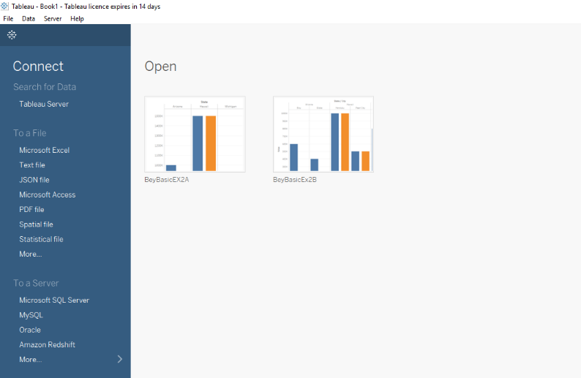

Figure 1.1

OR

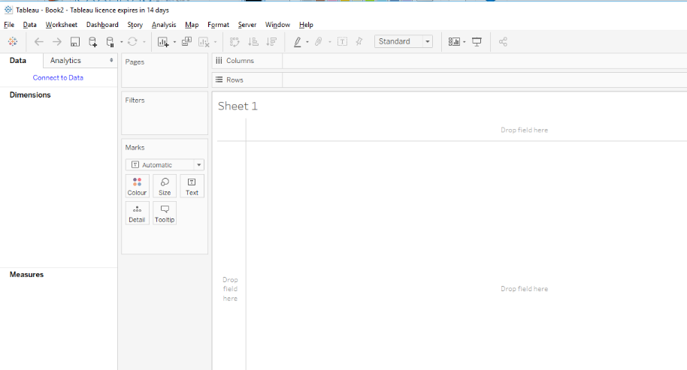

Figure 1.2

* 1. If you started in Figure 1.1, select the type of data sources you are using (In this exercise, an Excel spreadsheet)
  2. If you started in Figure 1.2, select either of these two:

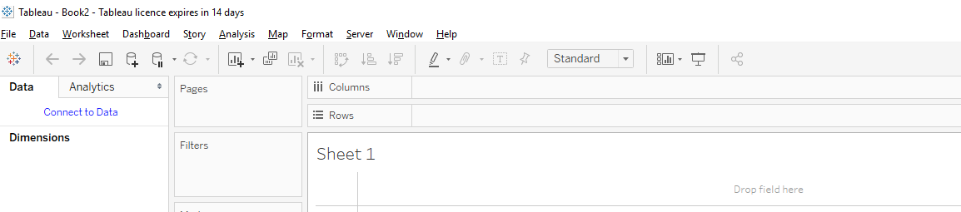

It will pop up a similar screen as Figure 1.1. Similarly, select the type of data source you are using (In this exercise, an Excel Spreadsheet)

1. Select ‘StateTourismNo.xlsx’ and click the open button.
2. Save this workbook as ‘BeyBasic2a’ as a ‘Tableau Packaged Workbook’ as shown:

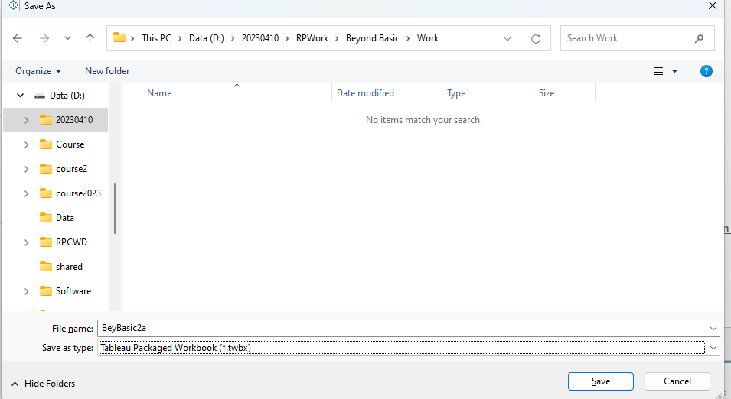

1. Select ‘File’ at the menu and save the workbooks three times as ‘Tableau Packaged Workbook’ and name each of the new workbook accordingly ‘BeyBasic2b’ and‘BeyBasic2c’.

You will need these two workbooks for understanding the concepts of Join and Blending

# Exercise 2: Comparing between Join and Data Blending

## Task 1: Performing a join

1. Select the ‘Data Source’ at the tab below

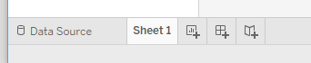

1. Click on the Add link and select the Excel spreadsheet ‘CityExpectedTourism.xlsx’

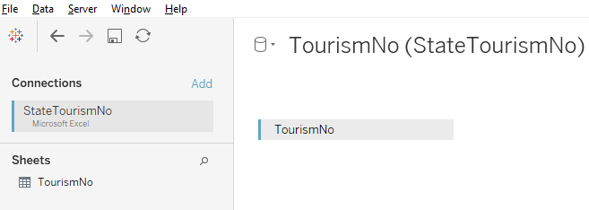

1. You should have the screen shown:

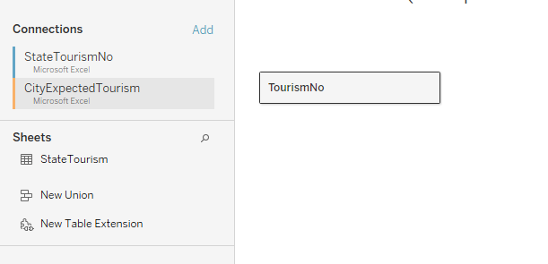

1. Move the cursor near the TourismNo table, and you should see this down arrow and click on it.

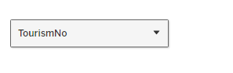

1. Select the open option.

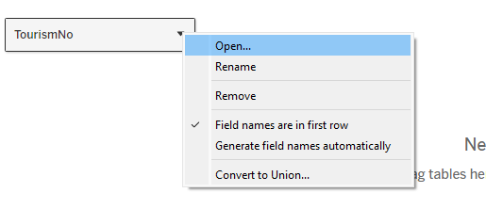

You should see this screen below and clicking the open option.

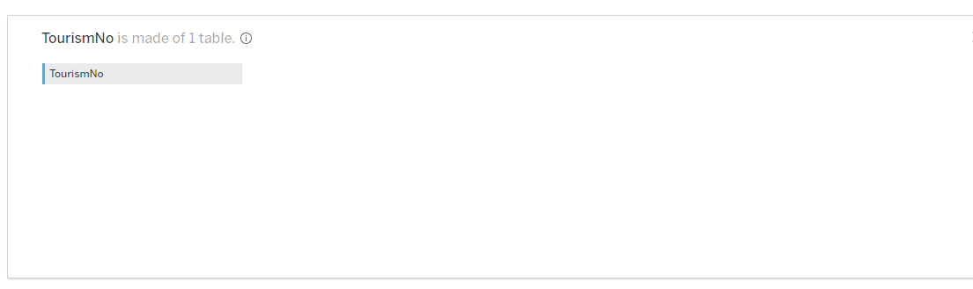

1. Select the ‘CityExpectedtourism’ table by clicking on it.

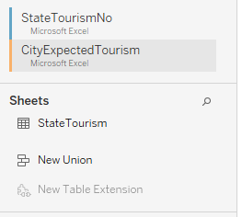

You should see this spreadsheet.

1. Click and drag the ‘StateTourism’ spreadsheet into the workplace.

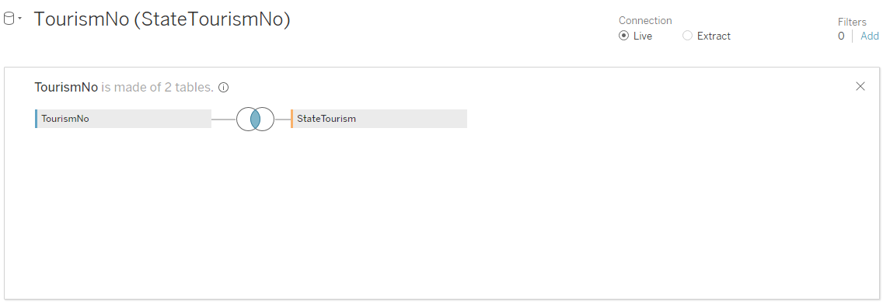

1. Click on the ‘Join’ connector.
2. Select the LEFT JOIN

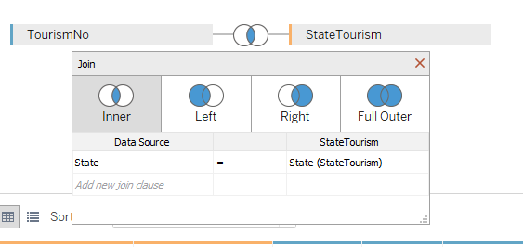

1. Now go to the Worksheet and drag the ‘State’ into column and ‘TouristNo’ and rows as shown:

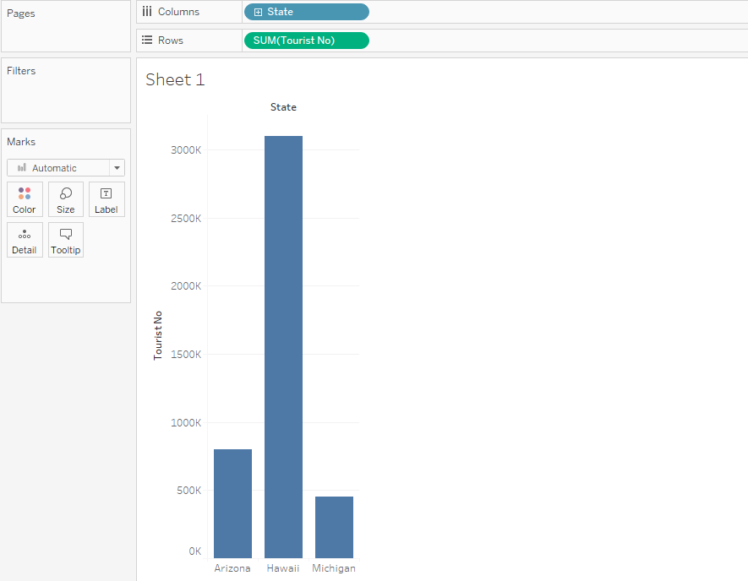

1. Select the ‘Expected Tourism Number’ field and drag until you can see the green bar and dotted line as shown. Hint Slowing drag from left to right.

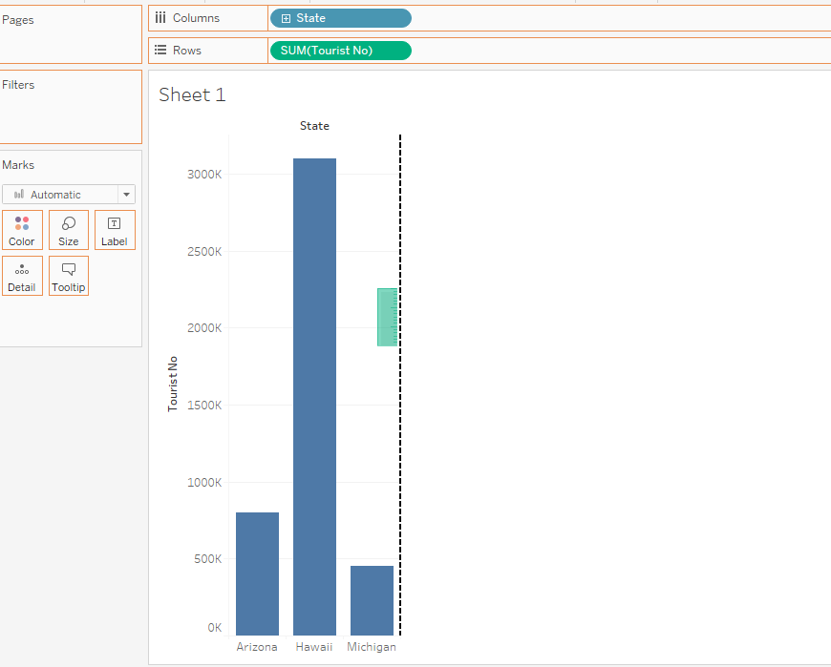

1. You will get the following screen:

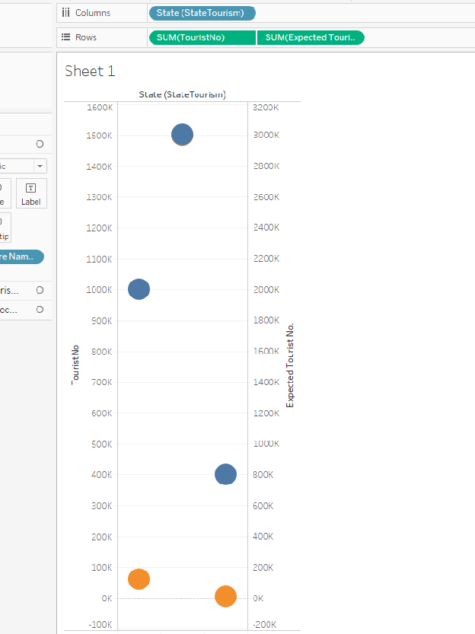

1. Go to the ‘Show Me’ Menu and select the ‘Side-by-side’ Bar as shown

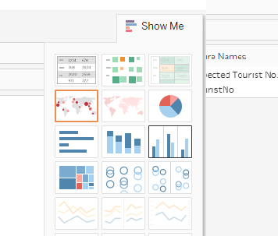

1. You will have a comparison bar chart. Do a mouse over the any of the ‘Expected Tourist No’ (Blue) bar. Compare the number of Expected Tourist Number found in the Excel Spreadsheet (CityExpectedTourism.xlsx) for the same state. Is the number correct?

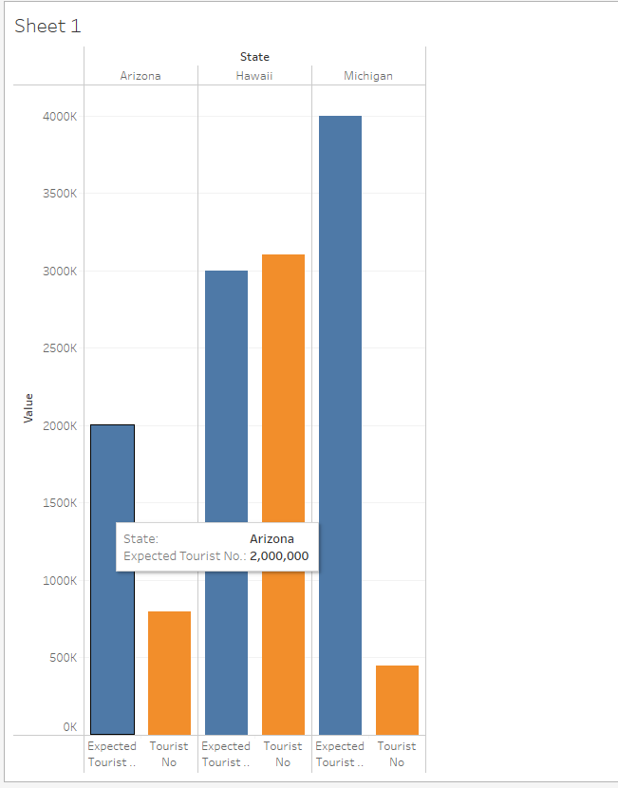

## Task 2: Performing a Data Blending (I)

1. Open the ‘BeyBasic2b’ workbook and go to the data source.
2. In this screen, click on this icon.

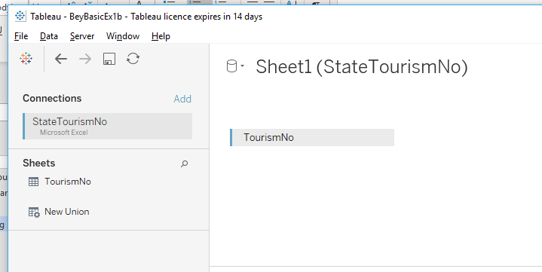

1. When the pop-up screen appears, select the ‘New Data Source’

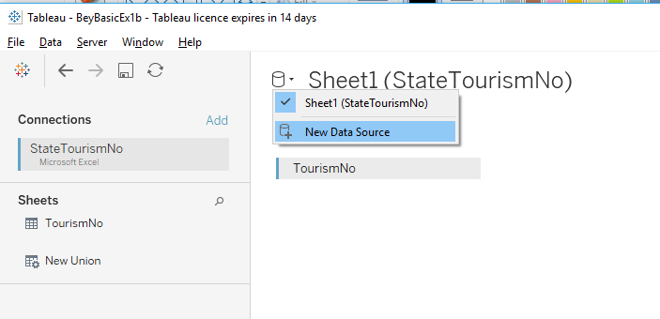

1. Select the ‘CityExpectedTourism.xlsx’ Excel spreadsheet.
2. Compare this screen with the one you have done the **join**. What is the difference?

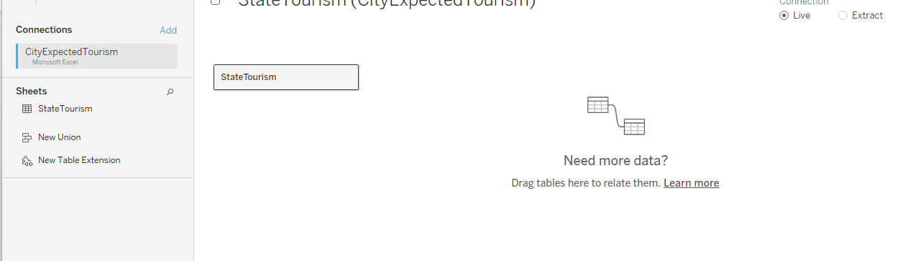

1. Go to the worksheet, how is this worksheet different from the Join worksheet?

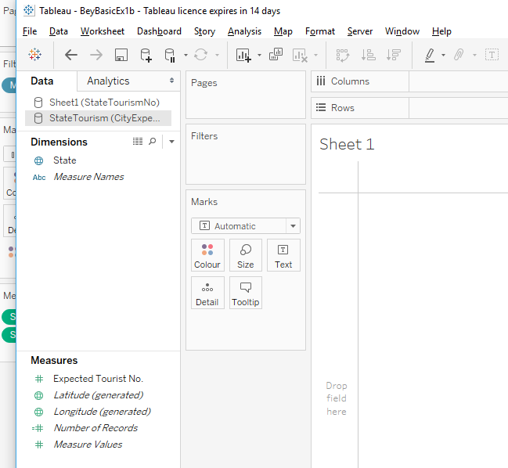

1. Select the ‘Data’ From the main menu and select ‘Edit Blend Relationships’.

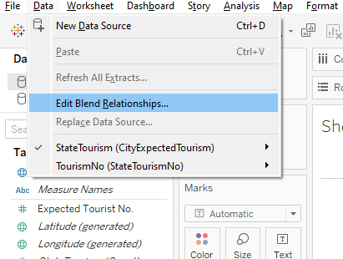

1. Determine which data source is the Primary Data Source (In this case, select ‘TourismNo (StateTourismNo)’ as Primary Data Source and ‘StateTourism(CityExpectedTourism)’ as Secondary Data Source) . Next, click ‘OK.

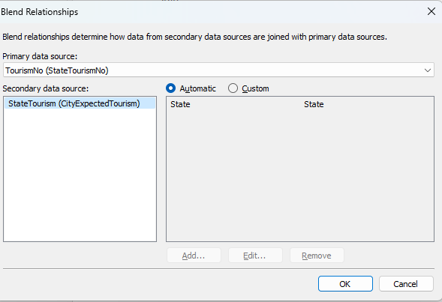

Note:

* 1. When both data sources have the same ‘State’ field, tableau will automatically select this field as the connecting field.
  2. In situations where the field name is different or the level of detail (e.g. ‘City’ is the connecting field instead of ‘State’), you may need to use the ‘Custom’ option to change the relationship.

1. Click and drag the ‘State’ field from the Primary Data Source -TouristNo (StateTourismNo) to the Column

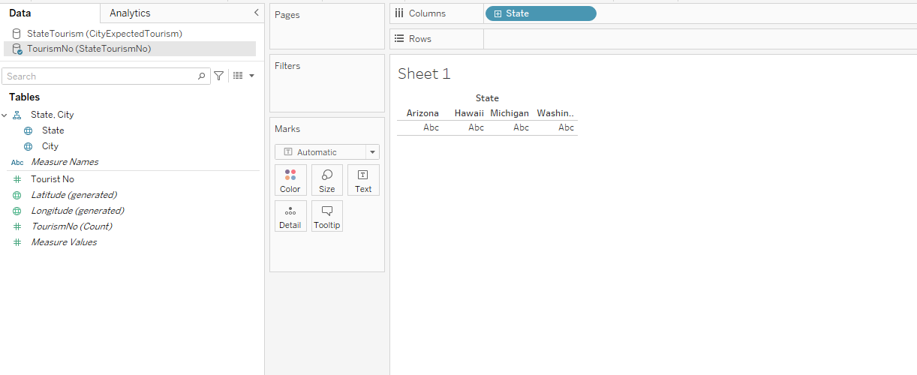

1. Click and drag the ‘TouristNo’ found in the measures (Primary Data Source)

Note: A bar chart is displayed.

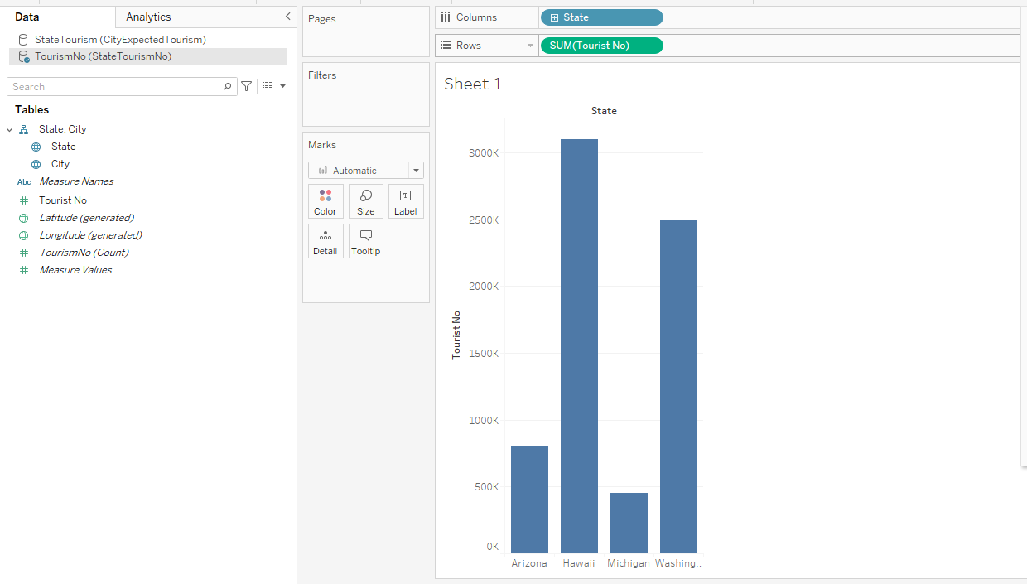

1. Now change to the Secondary Data Source (‘CityExpectedTourism’) by clicking on it.

Note:

1. It will display the fields from ‘CityExpectedTourism’ Data Source.
2. It will also a small ‘chain’ next to the ‘State’ field

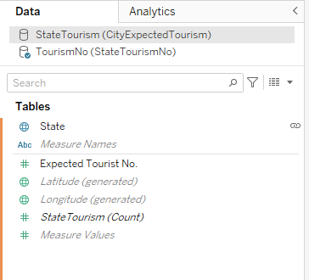

1. Select the ‘Expected Tourist No’ and drag to the spot shown by the green box and dotted lines.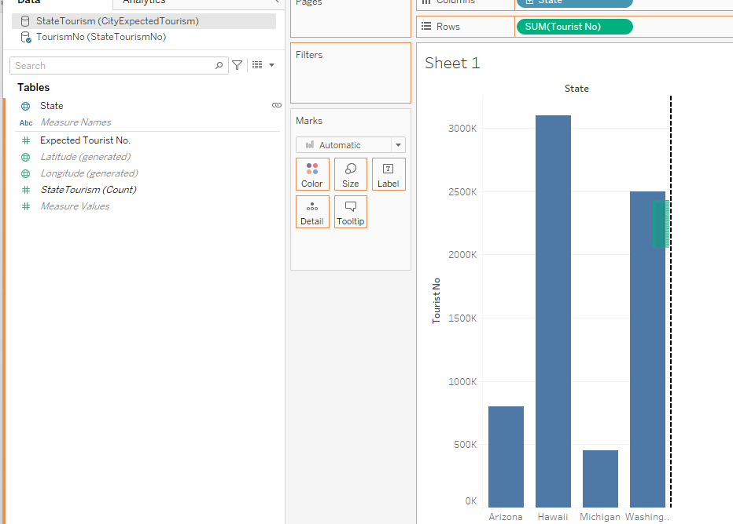
2. The following screen (partial) is shown:

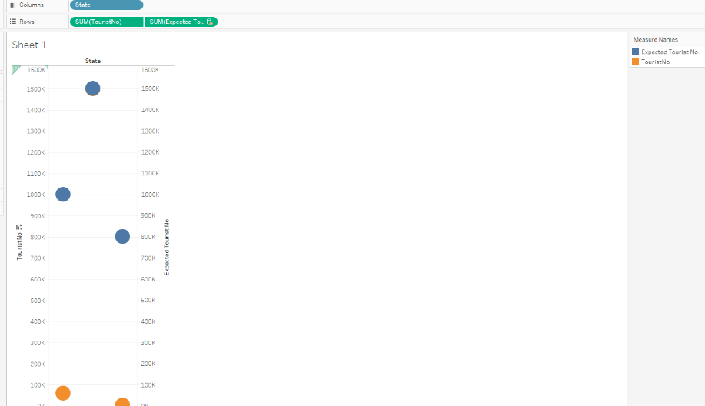

1. Select the ‘Show Me Menu’ and select the ‘Side-By-Side’ Bar Chart (as Shown)

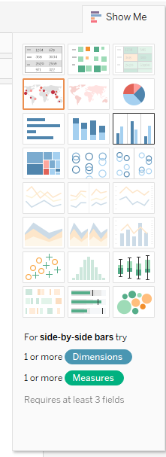

1. The following chart is displayed, mouse over the various bar and check ‘Expected Tourism No’

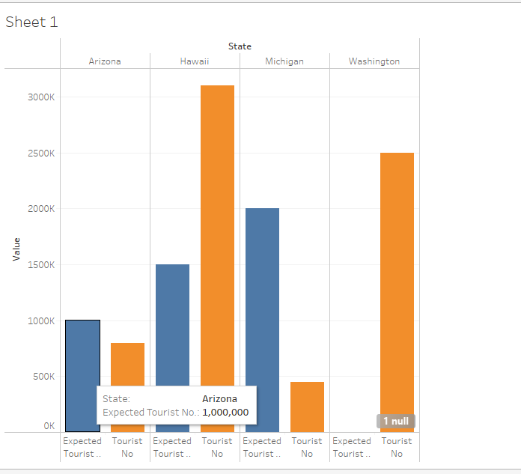

1. Compare the ‘Expected Tourist No’ Value to Task 1. Which charts show a more accurate ‘Expected Tourist No’?

(Check the numbers from both spreadsheets.)

1. At this point, you shown be able to ‘drill’ down the next level by clicking the  symbol.

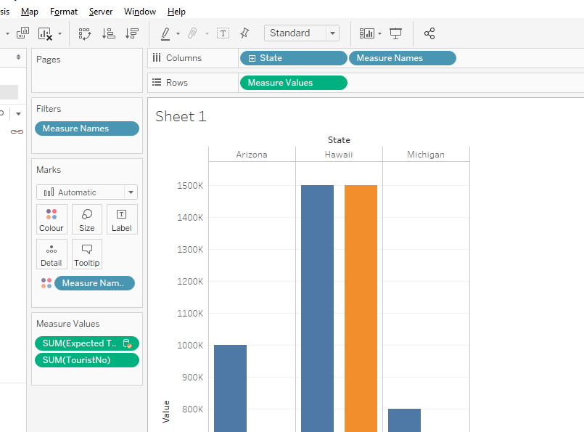

1. You will be able to see the breakdown of the tourism based on the city (as shown)

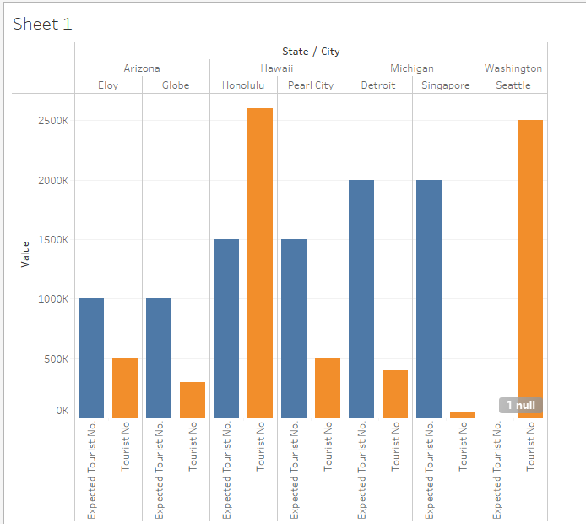

1. Save the changes.

## Task 3: Performing a Data Blending (II)

1. The steps in Task 3 is like Task 2.
2. Open ‘BeyBasic2c’.
3. When you perform Task 2 Step 4 for this workbook, choose ‘CityExpectedTourism2.xlsx’
4. Repeat all the steps mentioned in Task 2 and replace ‘CityExpectedTourism’ to ‘CityExpectedTourism2’ for all the steps for this task.
5. At the end of the tasks, you should get this outcome:

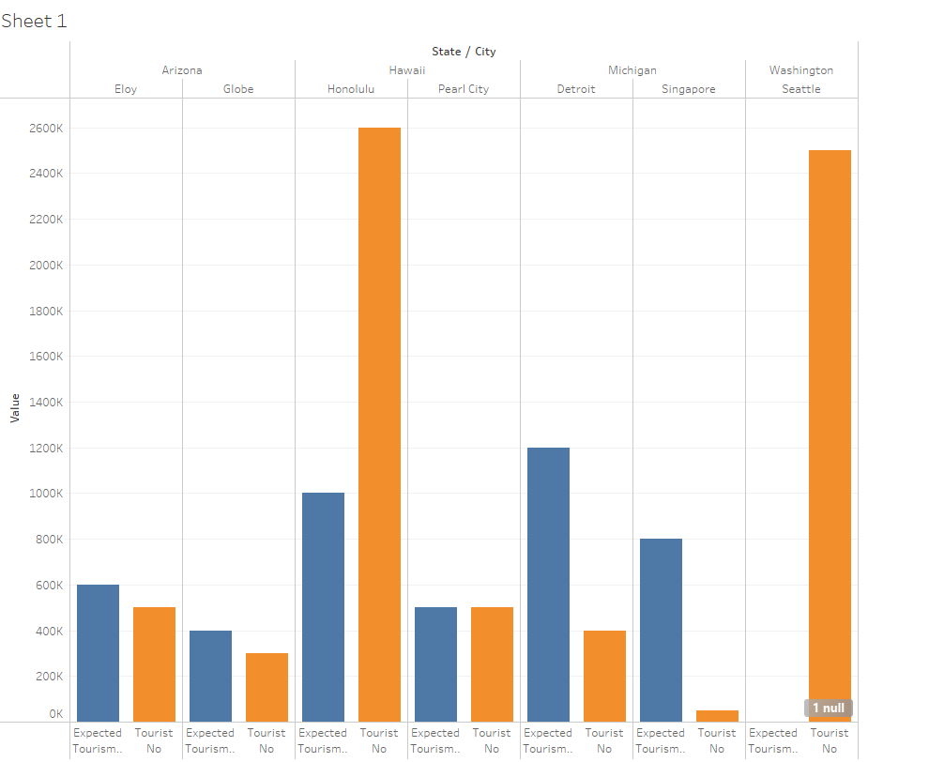

Final Note for Exercise 2:

Two small data sets are used to demonstrate the difference between a ‘Join’ and ‘Data Blending’. Understanding these two features will help you to improve on the accuracy of the presentation.

# Exercise 3 Data Union

Note: There are **deliberate** errors in the data sources

## Task 1: Using the Join or ‘Union’

1. Open the workbook ‘BeyBasic3.twbx’ found in the ‘Starter’ folder.
2. Save this workbook as ‘BeyBasic3T1.twbx’
3. Perform the Join with all the spreadsheets. Drag Q1 in the workplace first and click on the Open as shown:

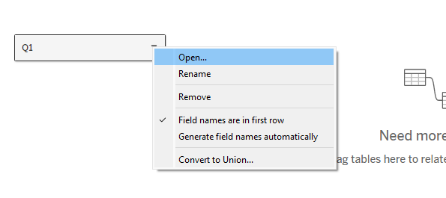

1. Now drag the all the different data sources into the as shown:

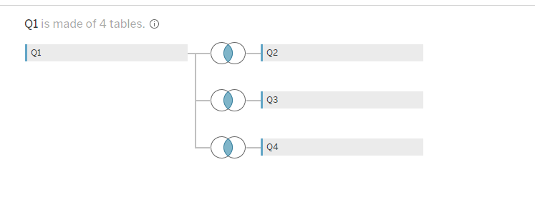

Note: The field that is connecting the data sources is incorrect. Tableau will assume the common fields found in each table(spreadsheet) is the connecting field. In this case, the ‘Sales’ field from Q1 is not related to the ‘Sales’ fields for Q2, 3 and Q4, but rather the ‘Category’ field from Q1to the ‘Business Unit’ field for Q2, Q3 and Q4

1. Click on each of the join and make the required amendment as shown:

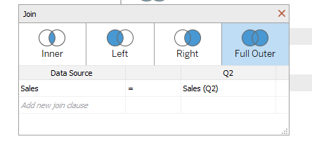

* 1. Change the join to ‘FULL OUTER’ as shown above
  2. Change the field that is joining ‘Category’ = ‘Business Unit’ as shown below: 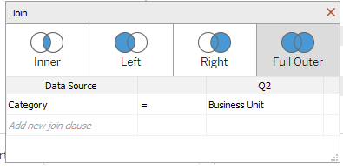
  3. Repeat the process for Q3 and Q4

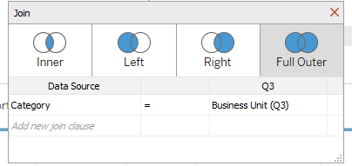(Q3)

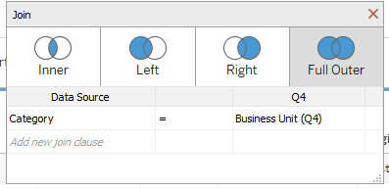 (Q4)

1. Observe the results from the join.

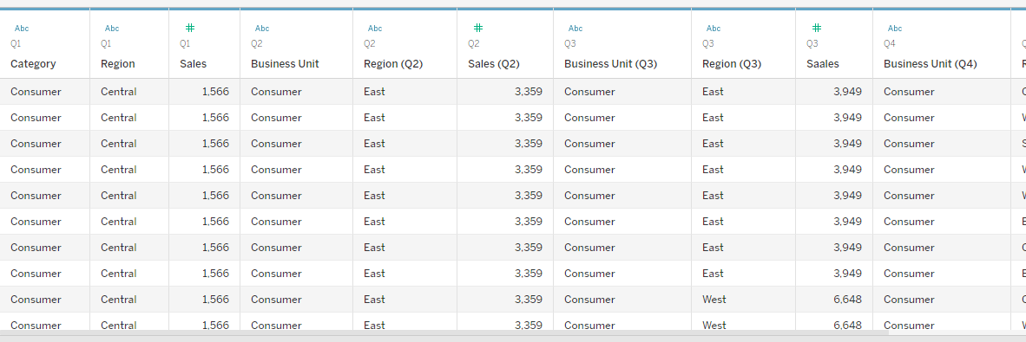

1. Go to the worksheet, observe how all the data sources you have added are organized.

## Task 2: Appending the record into a single data source

1. Open the workbook ‘BeyBasic3.twbx’
2. Save this workbook as ‘BeyBasic3T2.twbx’
3. Drag the ‘Q1’ data source as shown:

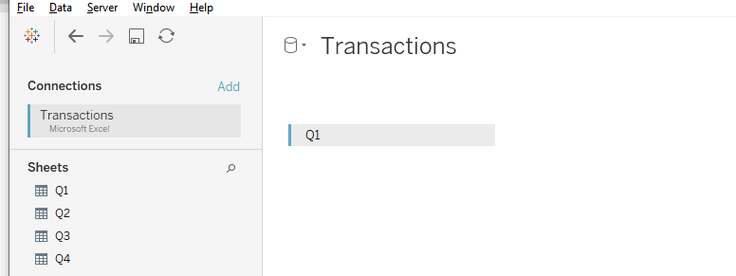

1. Next drag ‘Q2’ into the workspace as shown:

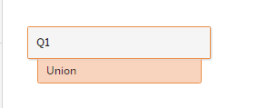

After you drag ‘Q2’ into the workspace, this will be the result:

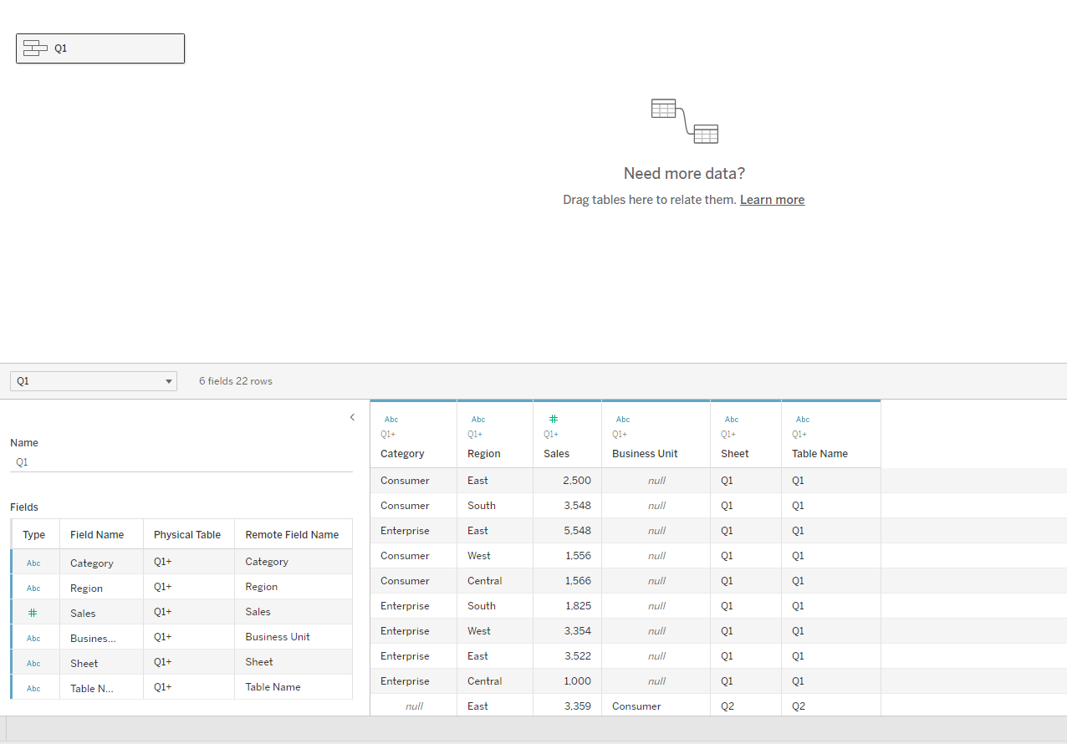

The image will show as the following

The presentation of the data is not what you want. Ignore this currently

1. Repeat Step 4 for ‘Q3’ and ‘Q4’
2. After completing step 5, you need to ‘correct’ some of the mismatch column names
3. Select the ‘Category’ and ‘Business Unit’ fields.

1. Do a mouse RIGHT-Click, select the ‘Merge Mismatched Fields’ option

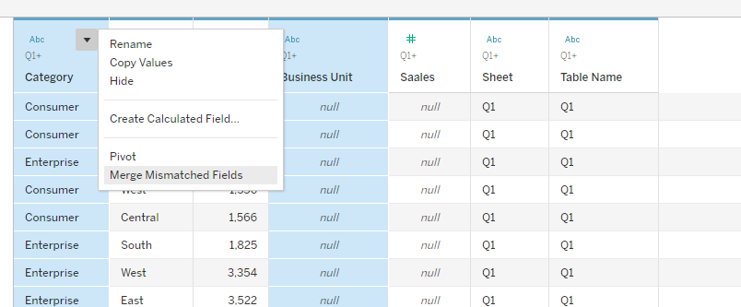

1. This will be the output:

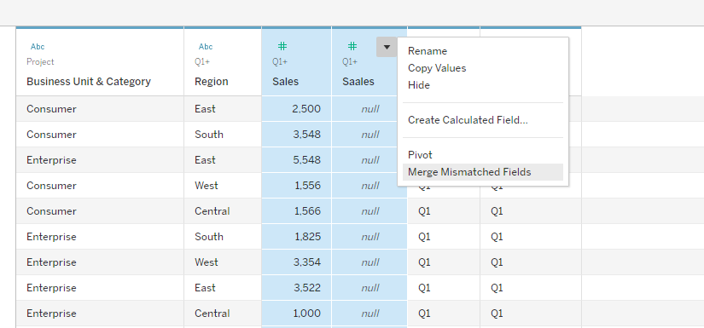

1. Repeat Step 7 and 8 for the ‘Sales’ and ‘Ssales’ fields
2. This will be the final output:

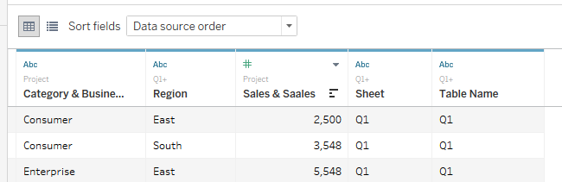

1. You can change the name of the field by clicking on it. For example, change ‘Category & Business Unit’ to ‘Business Unit’

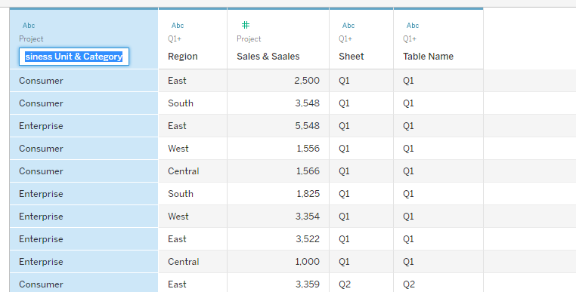

1. Repeat step 12 to change ‘Sales & Ssale’ to ‘Sales’.
2. Compare the data sets after you have done step 1 to 14 with the data from Task 1. Go the worksheet, observe how the data are organized in task 2 compared to task 1.
3. What is the advantage of the data arrangement in Task 2?

Exercise 3 makes a comparison between Union and Join. Union is more of appending record into a single file together. Join is to connect different tables and append at the end of each rows with fields.

# Exercise 4: Scenario One: Investment in Startups

You are to review a list of start-ups to determine which start-ups to invest.

Key criterion for selecting investments are based on the following combination of:

High Revenue (2015) and Low Revenue (2015)

Top Growth (2015)

You are required to determine which business has the best investment opportunities.

## Task 1: Fixing the incorrect Data Type

**THIS STEP MUST BE DONE FIRST**

There are occasions when Tableau may ‘misinterpret’ numeric value. In this case, the ‘Year Found’ field has been ‘misinterpreted’. It is important to check whether the data type of such fields.

1. Start a new workbook.
2. Select the ‘1000-startup.xlsx’
3. Drag the ‘Overview’ worksheet and the ‘Financials’ worksheet into the workspace for joining.
4. Perform an INNER-JOIN between the two data source.

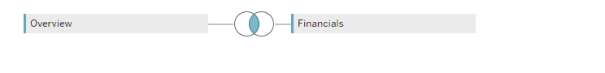

1. The ‘Year Founded’ field should be discrete. If the option shown is ‘Convert to Discrete’, like in this case, you need to click on the option.

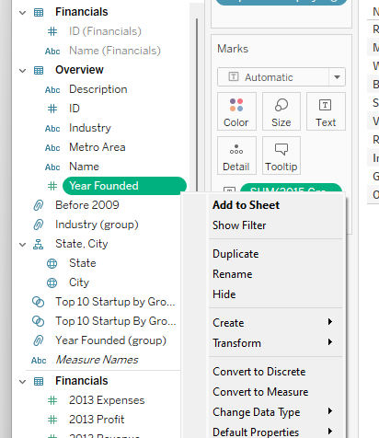

1. You can differentiate between a discrete value continuous value by the colour icon next to the field name (e.g. , , ).

If it is a discrete value, it should be BLUE.

If it is continuous value, it should be GREEN.

1. Save the workbook as ‘BeyBasicEx4’.

**Difference between Discrete and Continuous**

When you pick the field and drag into either row or column, did the field change?

If the field remain the same, it is a Discrete field

e.g. When the ‘Name’ (from either table) field is dragged into row, it remains the same

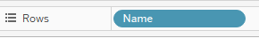

If the field changed to an aggregated function (e.g. SUM), this is a Continuous field

e.g. When the ‘2013 Profit’ is dragged into row, it become an aggregated function

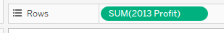

## Task 2: Organizing your workspace and data

This task is to prepare the data and how you can create folders in Tableau.

1. You can either organize your dimensions and measures by ‘Folders’ or ‘Data Source’
2. Let organize based on folders. Right Click on an empty portion of the Data Panel at the bottom

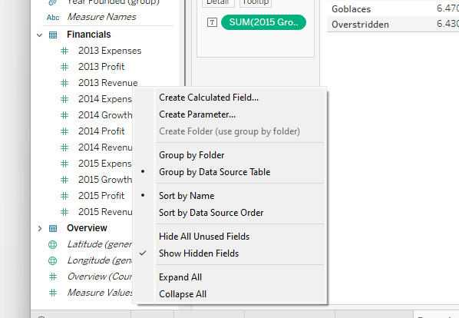

1. Select the ‘Group by Folder’ option and click.
2. All the data sources reference is hidden as shown:

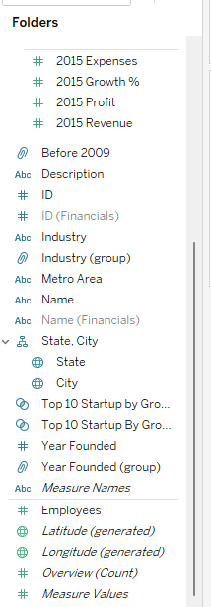

1. You may like to hide similar data fields (e.g. ID, Name). Select ID(Financials) and click on the down arrow as shown:

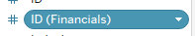

1. In the pull-down menu, select ‘Hide’ to hide the field.

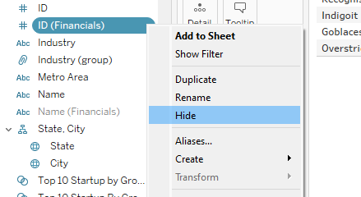

1. Repeat to hide the‘Name (Financials)’ field.

Note: Step 8 and 9 need not to be done. It is to demonstrate how you can unhide field(s).

1. You can unhide the fields by RIGHT clicking at an empty space (not next to any fields) in the Data Panel and select the ‘Show Hidden Fields’

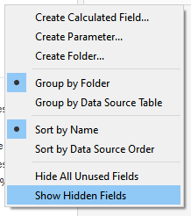

1. Select the hidden field that you like to unhide for example ‘ID(Financials)’

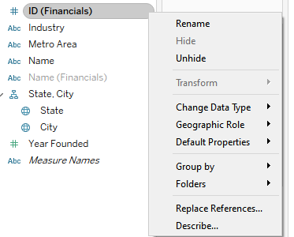

1. Now creating folders. Go to an empty space and RIGHT click.

Note: If you put your mouse cursors in ‘Dimension’, the folder will be created there

1. Select ‘Create Folder’ option.

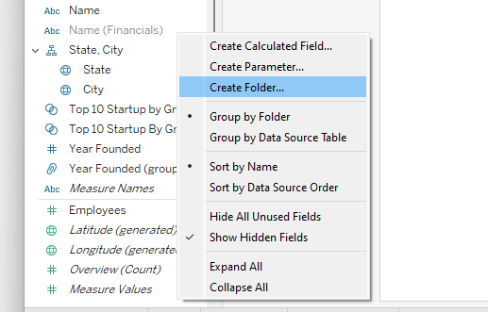

1. Name the folder as 2015 and click OK.

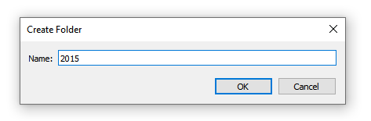

2015 folder created

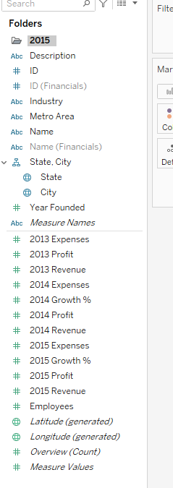

1. Select ALL the 2015 measures by holding the <Shift> key and clicking the left mouse button,

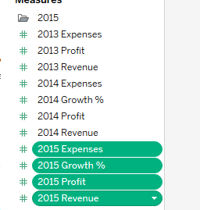

DRAG

1. Drag the selected fields into the 2015 folder.

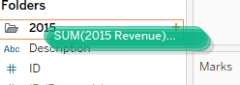

1. Repeat steps 11 to 14 for 2013 and 2014.

Your fields are organized into the respective and click open or close the respective folders for viewing:

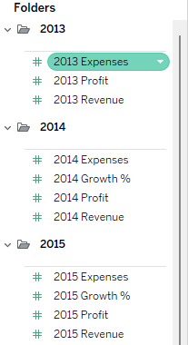

## Task 3: Working with the GROUP features (I)

1. Start New Sheet.
2. Drag the field ‘Year Found’ (Dimension) into the Column and the ‘Overview (Count)’ (Measure) into row.

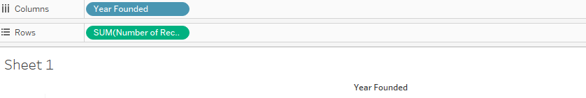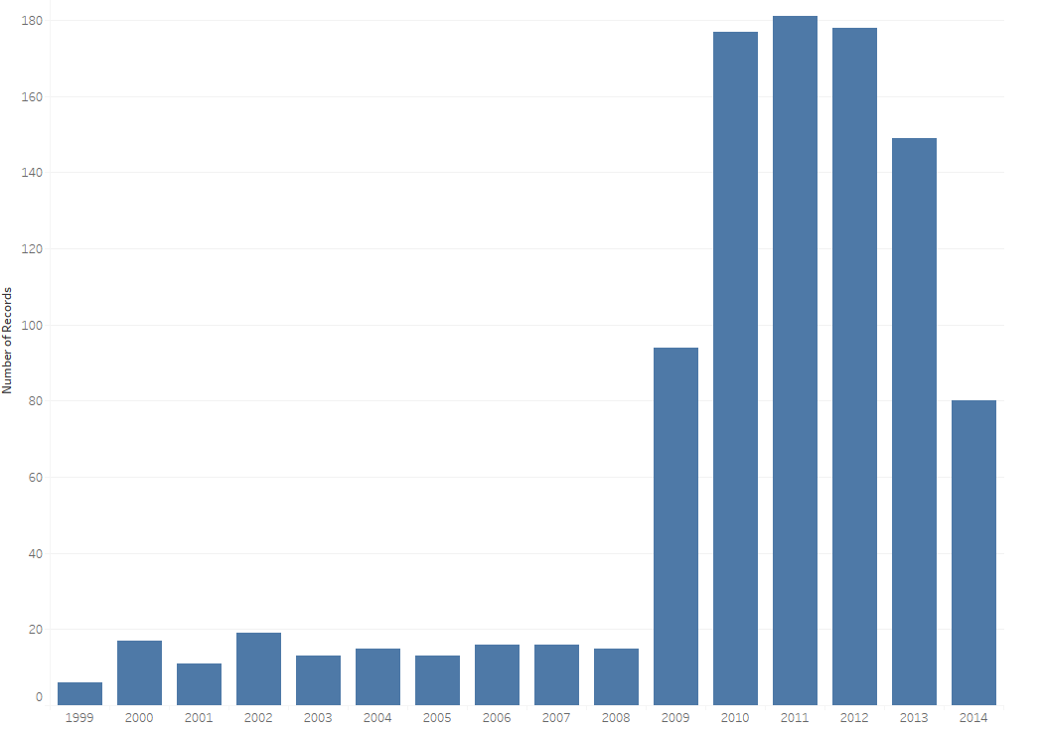

1. For example, you like to group all the ‘Year Found’ from 1999 to 2008. Click 1999 on the year axis, hold the <SHIFT> key and click 2008:

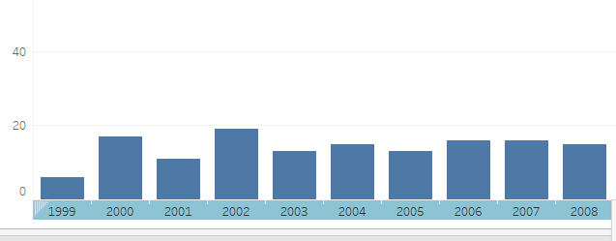

1. Either mouse over the selected area:

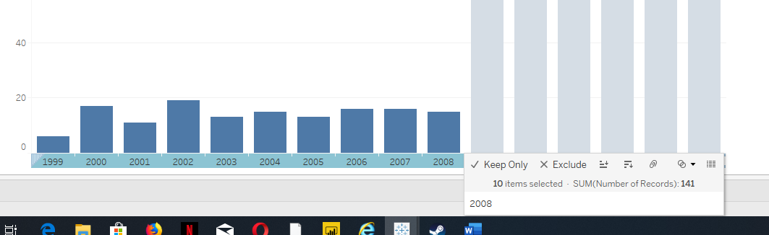

RIGHT mouse click.

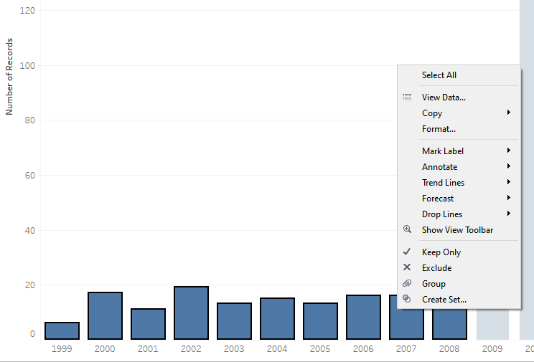

1. Click on the ‘Group’ option and create the Group.
2. You will get the following output screen:

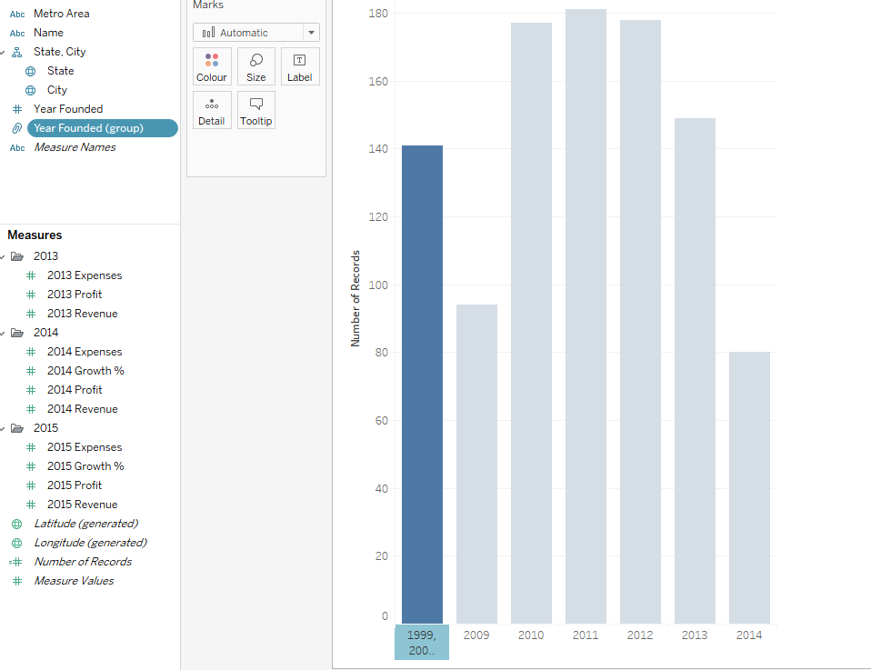 .

The sum (total) of the records found in the group

The group is created

1. If you did not get the above diagram, you have not done it correctly.
2. A ‘Year Found (Group)’ is created in the Dimensional area.

1. Rename the group name by clicking on the ‘Down’ arrow and selecting ‘Rename’

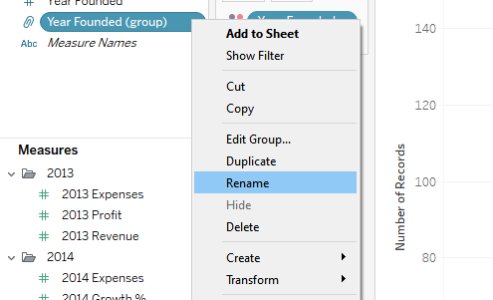

1. Change the group name to ‘Before 2009’

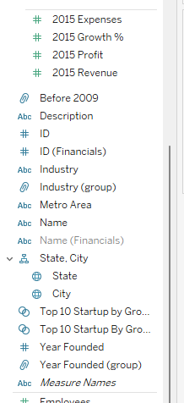

1. Editing the ‘Year Founded’ Group.

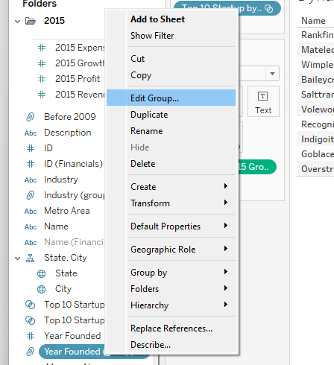

1. 1. If the group is not expanded, click on the down arrow as shown:

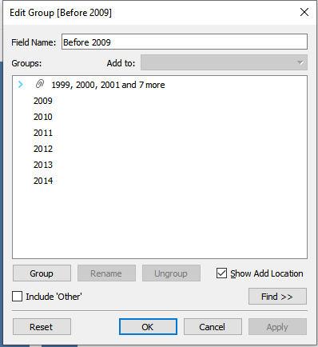

* 1. Select ‘2009’ and drag to the group. This will add the ‘2009’ to the group. Click ‘Apply’ followed by the ‘OK’.

1. Highlight the group as shown and click on the rename to change the label to ‘2009 and before’.

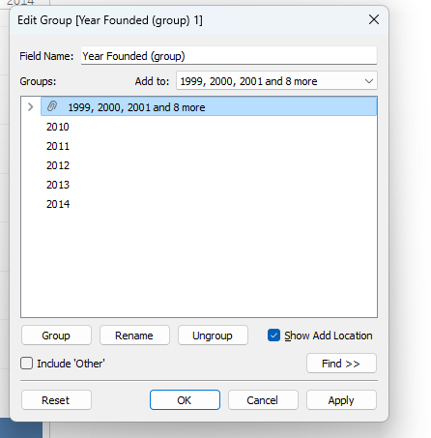

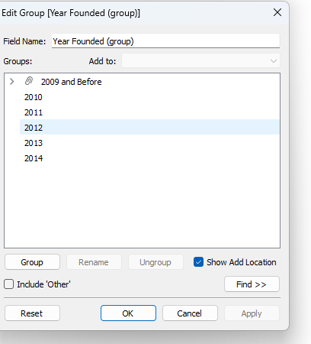

1. Rename the worksheet (Sheet1) as ‘By Year Founded’.
2. Save the workbook as ‘BeyBascEx4’.

## Task 4a: Working with the GROUP features (II) – Grouping Specific Industry Group

This task is to demonstrate the usage of groups. For example, we would like to know the average number of employee in each industry group. For some industries it can be classified as a particular group(e.g. Computer Hardware, Software and IT Services are grouped as IT Technology).

1. Start a new worksheet (By Industry Group)
2. Select the industry field and click on the down arrow.

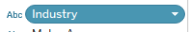

1. Next click on ‘Create’ followed by the ‘Group’

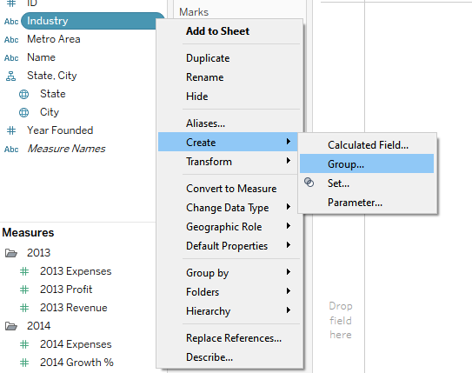

1. Change the name of the field group to ‘Industry Group’.

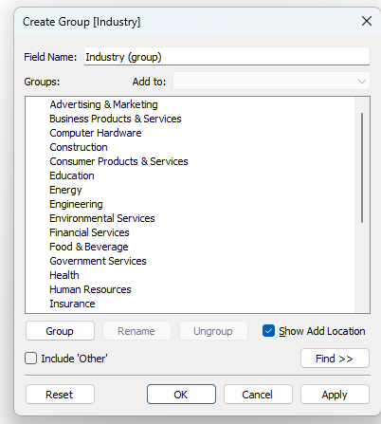

1. Select the following industries: ‘Computer Hardware’, ‘IT Services’ and ‘Software’.
2. Click the ‘Group’ button. Change the name of the new group to ‘Information Technology’

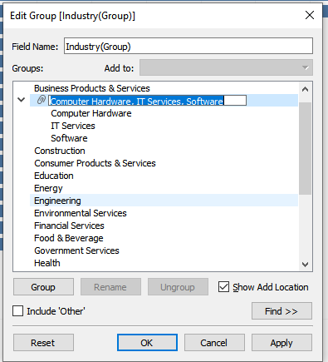

1. Click APPLY and ‘OK’.
2. The new group ‘Industry (Group)’ is now created at Dimension.
3. Now edit the group and add ‘Telecommunication’.
4. Remember to save your work.

## Task 4b: Create the Industry Chart

1. You are to create a chart that shows the average of employee by each Industry

Hint: Use the Industry (Group)

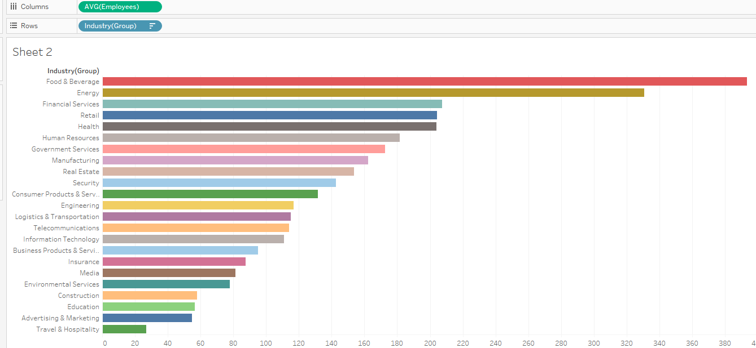

1. It is required to be sorted from highest average employee to lowest.

Final Note:

In Group, the aggregated function will be computing accordingly. For example, the average values of the Construction and Environmental Services are 57.9 and 78

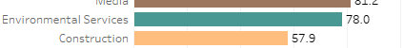

When you group these two data categories, the average will be 61. Basically, it will take the TOTAL number of employee from BOTH data categories divided by TOTAL number of employees.

It will not compute average of average value, in other word (78 + 57.9)/2 = 67.95 

## Task 5a and 5b will be demonstrated by trainer.

## Task 5a: Creating Static Sets

1. Add a new worksheet and called it ‘By Industry (SET)’
2. Drag ‘Name’ into Row and ‘2015 Growth %’ into the Marks panel.

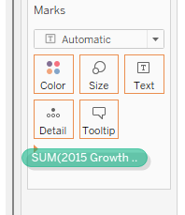

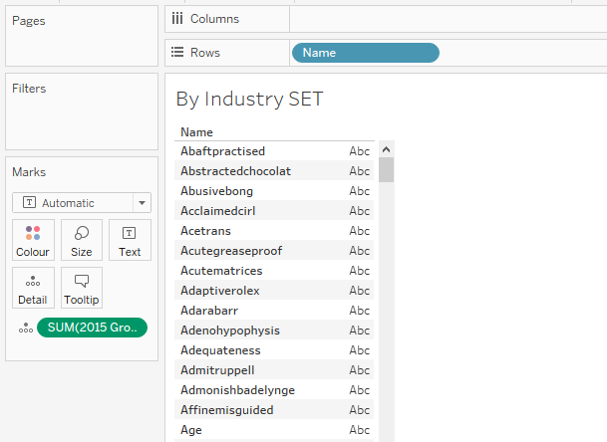

1. Change the ‘SUM(2015 Growth %)’ from details to Text by clicking on the  icon and select the ‘Text’

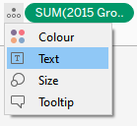

1. From this screen, click on the ‘Sort (Descending)’ button

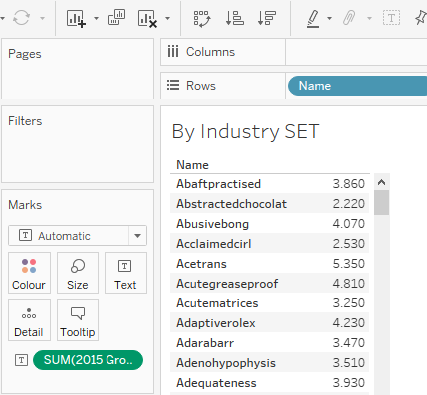

1. Select the TOP 10 records from the list by holding on the <SHIFT> key with the LEFT mouse button.

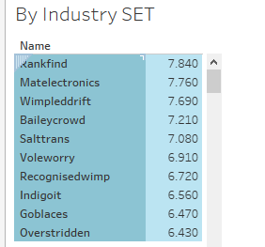

1. Either you RIGHT click at this area only

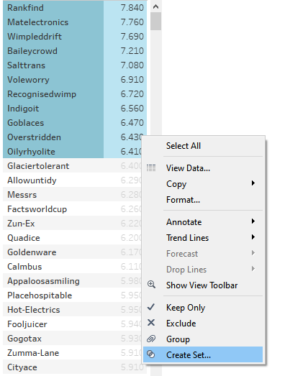

1. OR <SHIFT> and click over the coloured areas

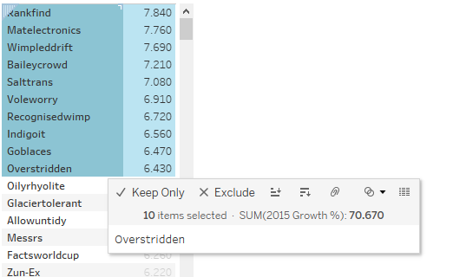

1. Click on ‘Create Set’ option.
2. Name this set as ‘Top 10 Startup By Growth Static’ and click OK

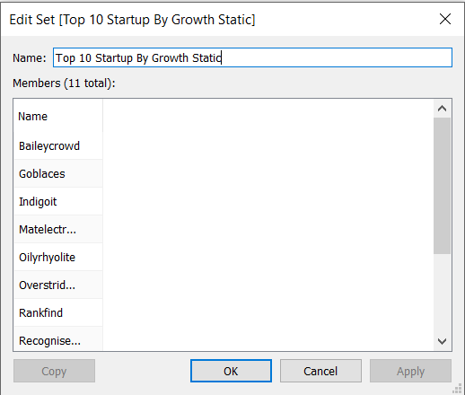

1. You will see the new set at the Data Panel as shown:



1. Drag the set to the filter panel. You will see the Top 10 Startup by Growth
2. The table will show the Top 10 startup companies.
3. Based on the static set you have created in Task 5a, what is a possible disadvantage of using static set?

## Task 5b: Creating Dynamic Sets

1. Start a new worksheet and name it ‘Dynamic Set’
2. Select ID from the Dimension and click on the arrow  next to the field.

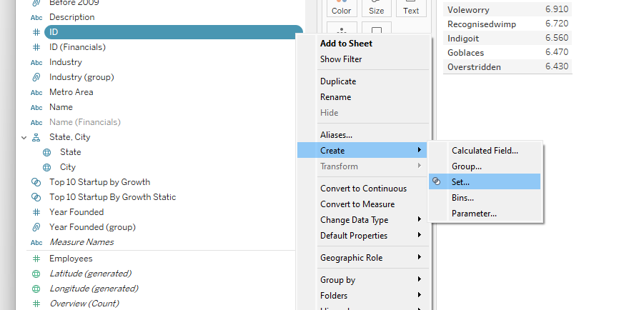

1. Select ‘Create’ followed by ‘Set’.

Note: We are using ID in this case as it is more unique. There may be duplicate ‘Name’ value.

1. In this pop out screen, select ‘Use All’ radio button.

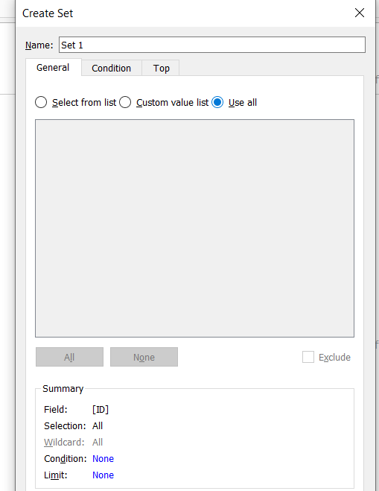

Note:

In this case, it is better to select ‘Use All’ as new value may be added to the data sets. If you make use of ‘Select from list’ option, new values added to the data file may not be included in the list.

1. Rename the set to ‘Top 10 Startup By Growth’.
2. Next, select the ‘Top’ option.

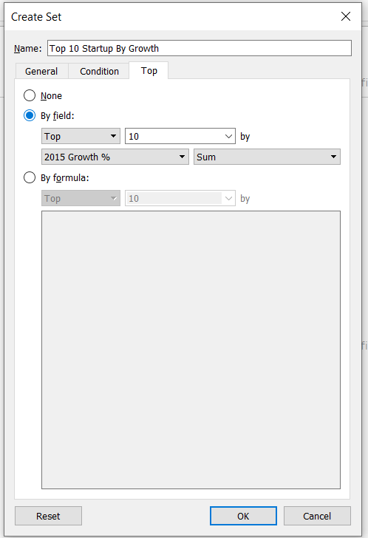

Change to 2015 Growth %

Default at 10

1. Change from ‘None’ option to ‘By Field’ option and click ‘OK’.
2. Drag ‘Top 10 Startup By Growth’ to the filter panel
3. Repeat Exercise 4 Task 5a step 2 to step 4 for this worksheet.
4. Observe the result and take note of the Top 10 Startup companies.
5. Save the workbook and exit Tableau.
6. Open the ‘1000-startup.xlsx’ spreadsheet. Go to the ‘Overview’ tab in the excel spreadsheet.
7. Search for company called ‘Appaloosasmiling’ in the ‘name’ column.
8. Go to the ‘2015-Growth %’ column and change the value from 598% to 1598%. Save the spreadsheet.
9. Start the tableau workbook again. Go to the ‘Dynamic Set’ worksheet. Compare the result. The startup ‘Appaloosasmiling’ will now have the highest 2015 Startup Growth. Now check the ‘By Industry Set’ worksheet. In the static set, the data reflected remain the same.

# Exercise 5: Data Extract

Note: There are 16, 798 records in the data sets. Do observe what is the number after you perform the data extract.

The objective of this exercise is to allow you to extract specific data for analysis using ‘Extract Data’ option.

## Task 1: Data Extract

1. Open the workbook ‘BeyBasicEx5.twbx’
2. Go to the Data Panel and RIGHT click on the ‘Orders’ Data source

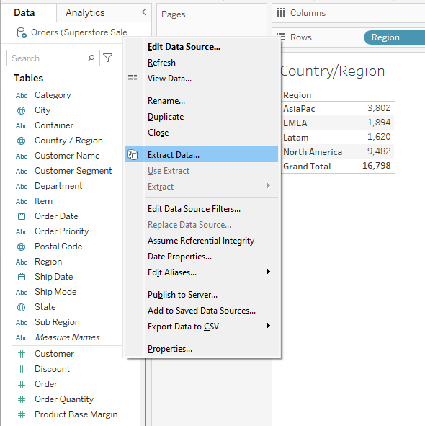

1. Select ‘Extract Data’ from the menu, it will show the following pop-up screen
2. Under the filter portion, select ‘ADD’ as indicated and select ‘Country/Region’

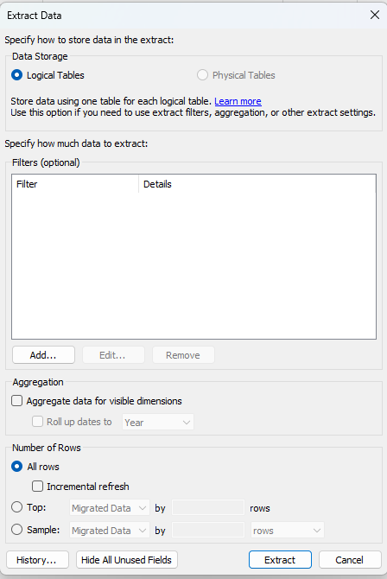

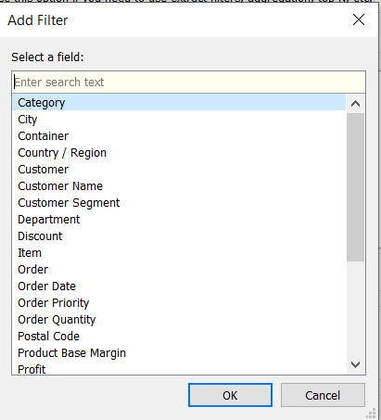

1. Select ‘United States of America’ from the list

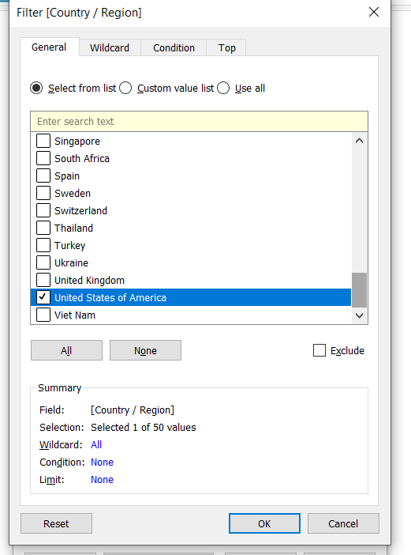

1. Click ‘OK’
2. In this dialog box, ensure the following are selected:

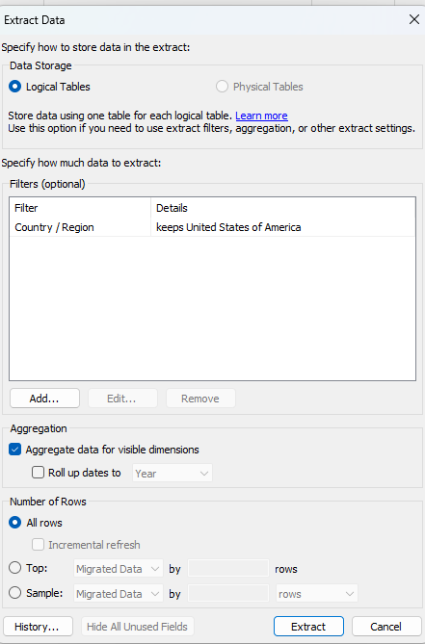

1. Click on ‘Hide All Unused Fields’ button, followed by the ‘Extract’ button
2. If you are prompt ‘Save As Extract’, type in ‘Sales Training’ and click ‘Save’
3. Go to the Country/Region, you should see there are only 9,426 records

## Task 2: Hide and Seek

1. Create a new worksheet called ‘Geographic Sales’
2. Right Click on the Order data source and unchecked ‘Use Extract’

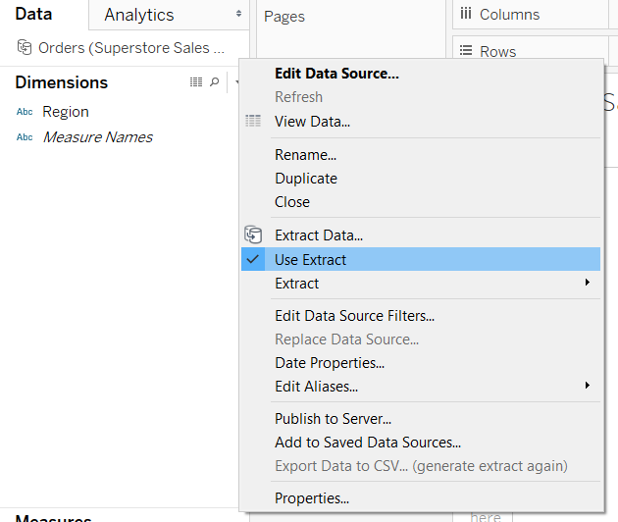

1. Right Click on any Blank space in Dimension or Measures as shown (e.g. Measure):

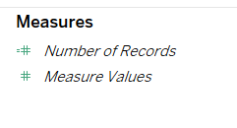

1. Select ‘Show Hidden Fields’

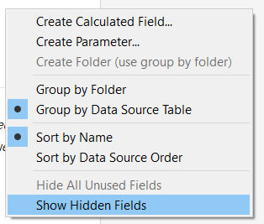

1. Click on the down arrow next to Country/Region fields

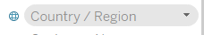

1. Select ‘Unhide’ from the menu

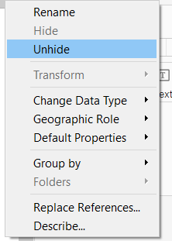

1. Repeat these steps to unhide ‘States’, ‘Profit’ and ‘Sales’ fields
2. Drag the following fields in the Marks Panel

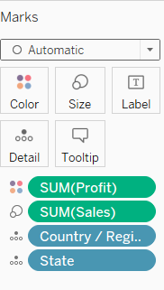

Detail

Size

Color

1. If your worksheet did not show a geographical map, go to ‘Show Menu’ and click on the ‘Symbol Maps’

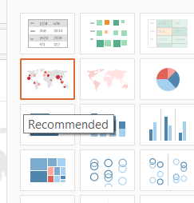

1. RIGHT click on the ‘Orders’ data sources and select ‘Extract Datat’
2. In the Data Extract menu, check there is filter for ‘United States’ and click on the ‘Extract’ button
3. This is the result you should get:

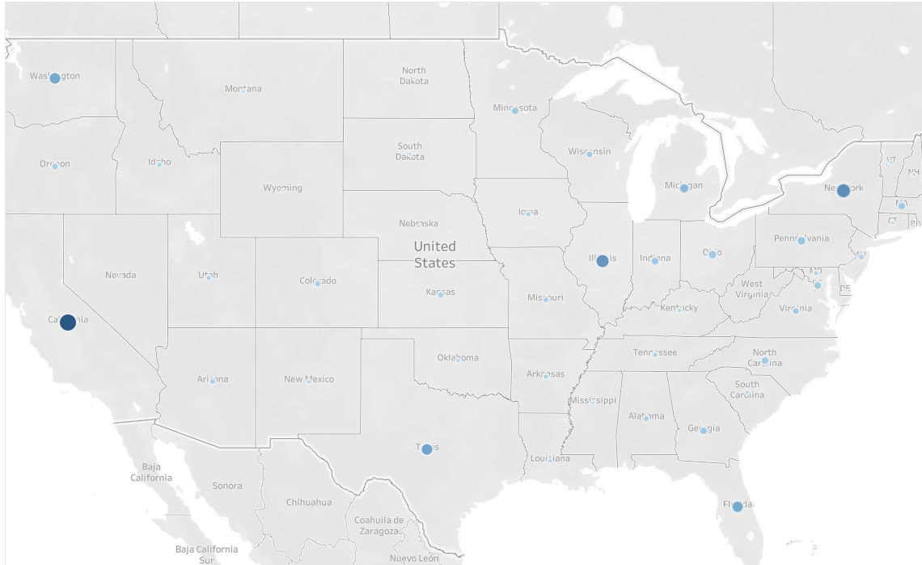

# Exercise 6: Calculation and Aggregation

## Task 1: Overall Profitability

1. Open ‘BeyBaicEx6.tbwx’

Note: The data for this worksheet has been prepared for you.

1. Go to the ‘Overall Profitability’ Worksheet and select the fields as shown:

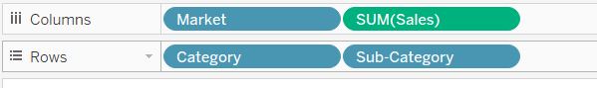

1. Create a ‘Calculated Field’ called ‘Overall Profit ?’

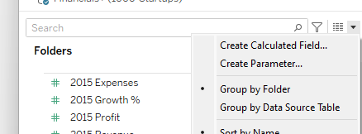

1. Use the Sum Function and drag the field into the Sum function. Complete the formula as shown.

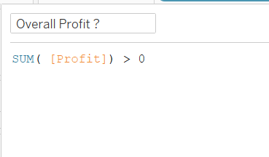

Click ‘OK’

1. Drag the new Calculated field (Overall Profit) into the ‘Color’ inside the Marks Pane

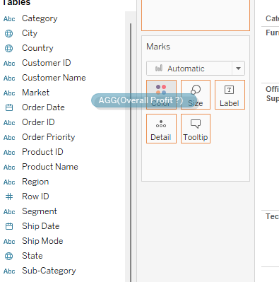v

1. Change the color for ‘False’ to Red and ‘True’ to Blue

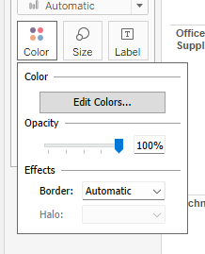

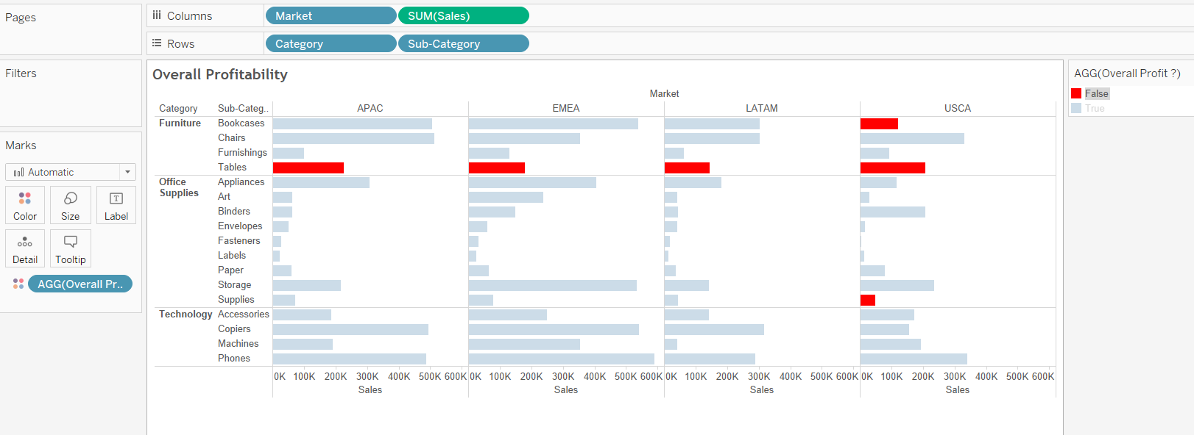

In this task, we have created a visualization to show which sub-category is making a loss (Represented in Red)

## Task 2: Profitability By Transactions

1. RIGHT click on the ‘Overall Profitability’ worksheet and select ‘Duplicate’ as shown:

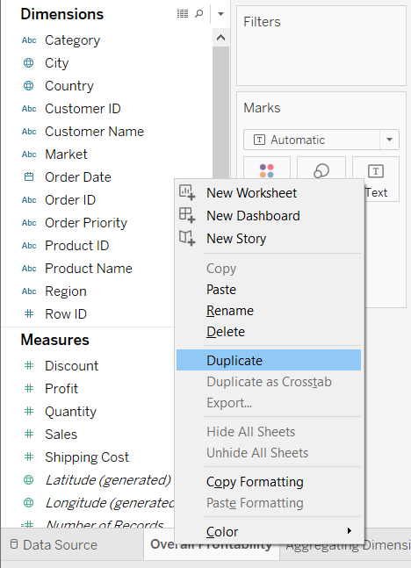

1. Rename the duplicated worksheet as ‘Profitability By Transactions’.
2. Create a Calculated Fields called ‘Profit By Transaction?’
3. Type in the following formula:

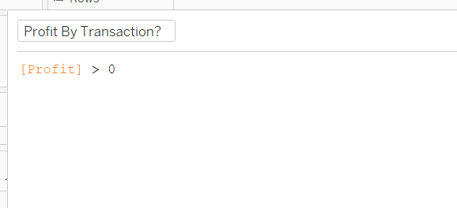

Click ‘OK’

1. Drag the ‘Profit By Transaction?’ into the Color in Mark Pane

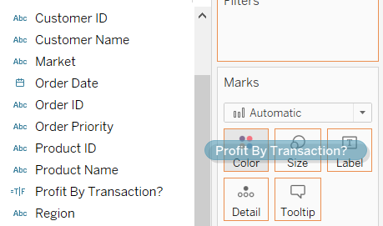

1. You should get this image

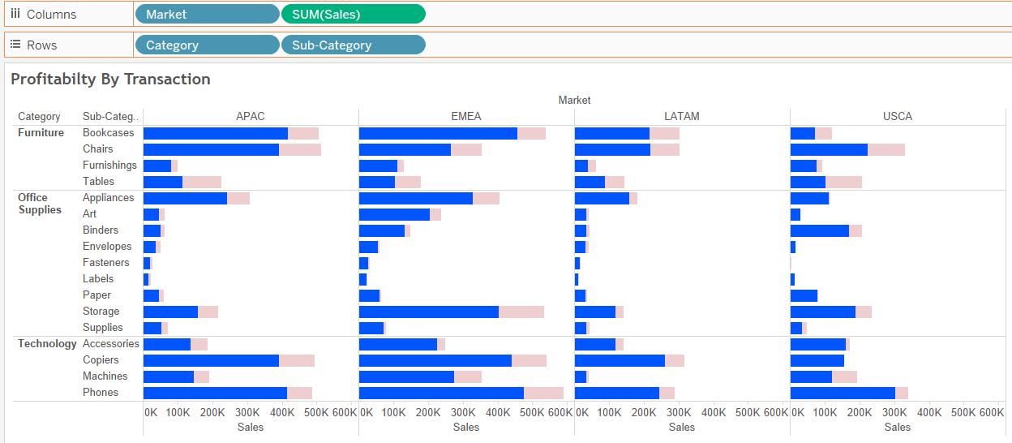

## Task 3: Aggregating a Dimension

1. Go to the Aggregating Dimension worksheet
2. Drag the required fields to the required row and column as shown:

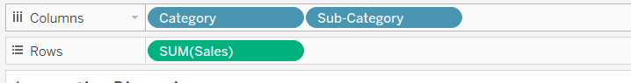

1. Drag the field ‘Profit’ into Color in the ‘Marks’ Pane as shown:

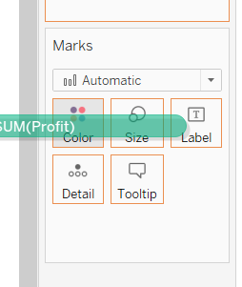

1. Create a calculated field called ‘Category with Profitability’. Use the following formula:

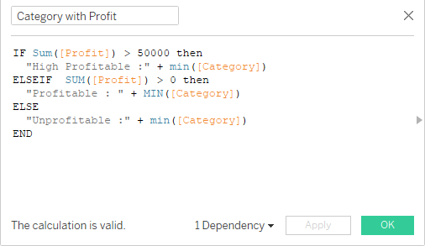

Click OK

1. Drag the ‘Category with Profitability’ calculated field between the Category and Sub-category field as shown:

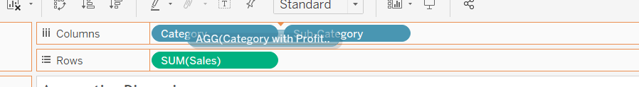

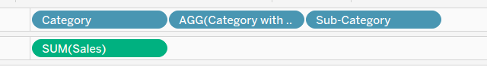

1. This will be the output:

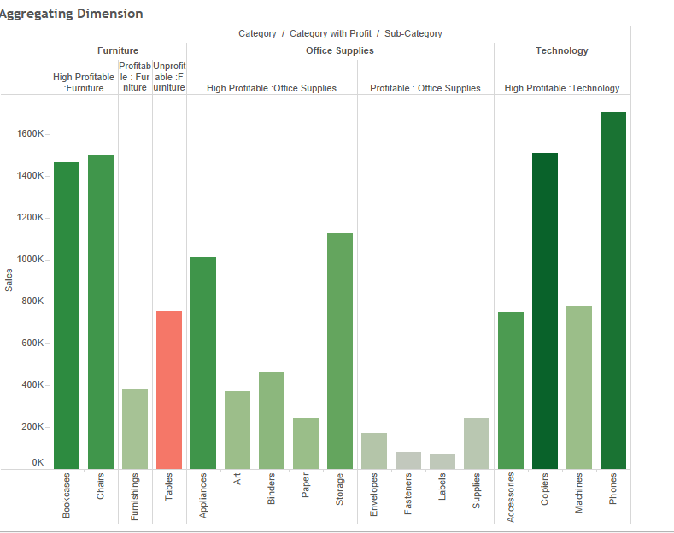

Task 3 is an example where it helps to provide the organization with more detailed information. For example , it helps to breakdown High profitable categories to Unprofitable categories.

Note: Do Save your workbook ‘BeyBasicEx6’

# Exercise 7: Table Calculation

## Task 1: Scope and Directions

1. Open workbook ‘BeyBasic7.twbx’
2. Go to the ‘Sum(Sales) in the Marks Pane and select ‘Quick Table Calculation’
3. In the drop-down menu, select ‘Percent of Total’

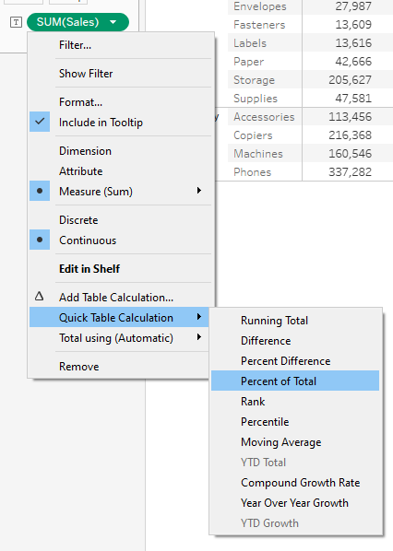

1. You will get a screen that shows the percentage of the sales across a row. This is the default selection
2. Click on the down arrow next to ‘Sum(Sales)’ and select the ‘Edit Table Calculation’

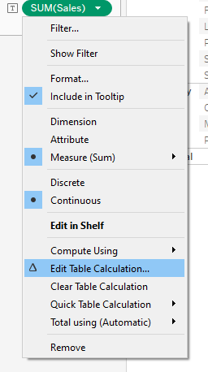 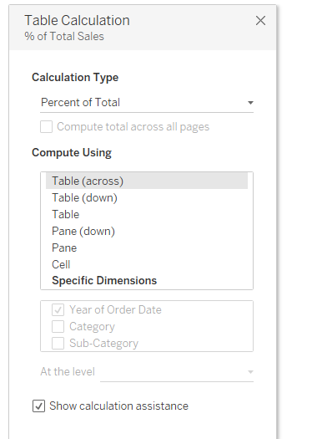

Pop up

1. Select ‘Table (down)’ option. This will calculate the percentage at column level

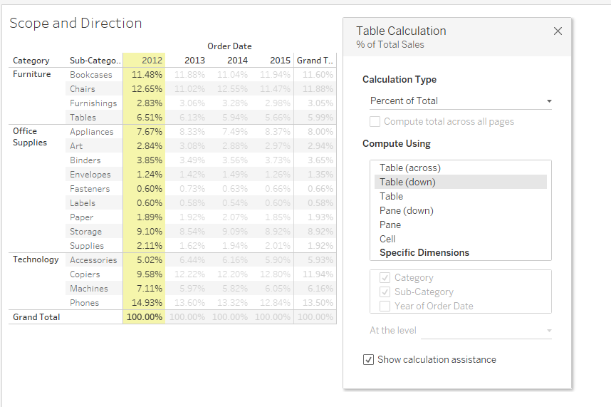

1. In this task, it demonstrated how the direction calculation can be changed. You are also able to specify the dimension to determine the calculation
2. Remember to save your work

## Task 2: Profitability (Percent of Total)

1. Start a new worksheet and name it ‘Profitability (Percent Total)’
2. Drag the respective fields into columns and rows

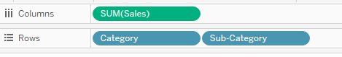

1. Create a Calculated fields called ‘Profit and Loss’ with the following formula:

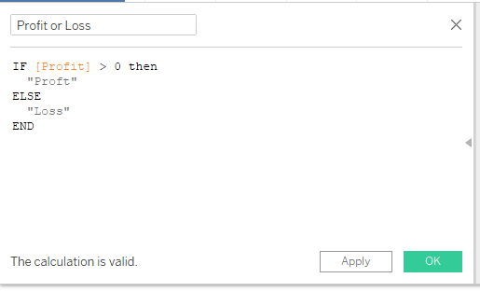

Remember to click ‘Ok’ to create the calculated field

1. Click on the SUM(Sales) down arrow and select ‘Add Table Calculation’

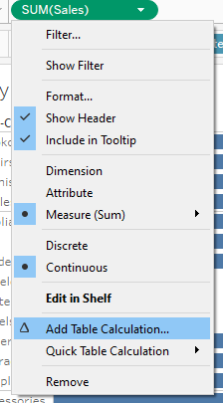

1. Do the following steps in sequences:

Step 3: Select ‘X’

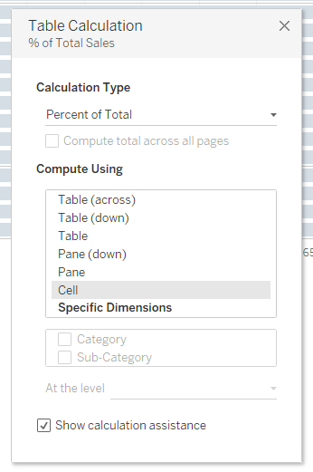

Step 2: Select ‘Cell’

Step 1: Select ‘Percent of Total’

1. You should get the following screen:

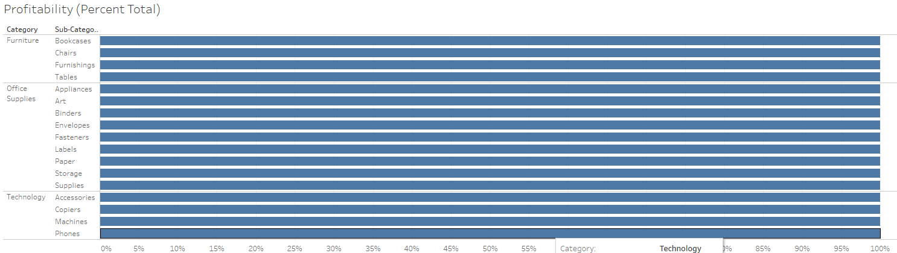

1. Select the calculated field ‘Profit or Loss’ to the ‘colors’ in the Mark Panel

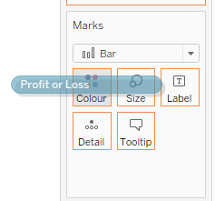

1. Hold the CTRL button and drag a copy of ‘SUM(Sales) to Label

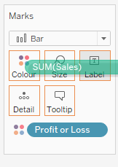

1. Click on the arrow next to SUM(Sales)

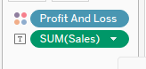

1. Select the ‘Add Table Calculation’ option.

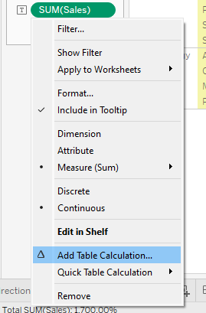

1. In this pop up menu, select the following options shown and select the ‘X’ to close menu:

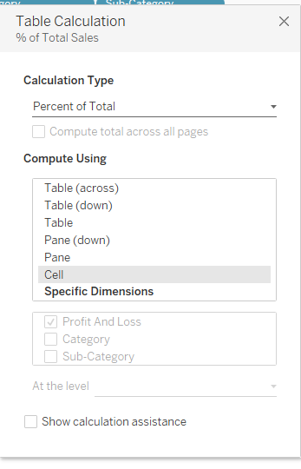

1. It will show the %Sales in the chart.

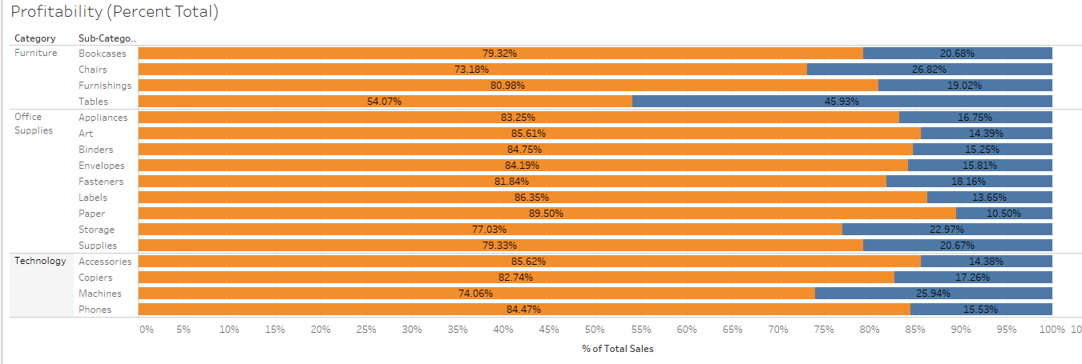

1. How would you create this chart?

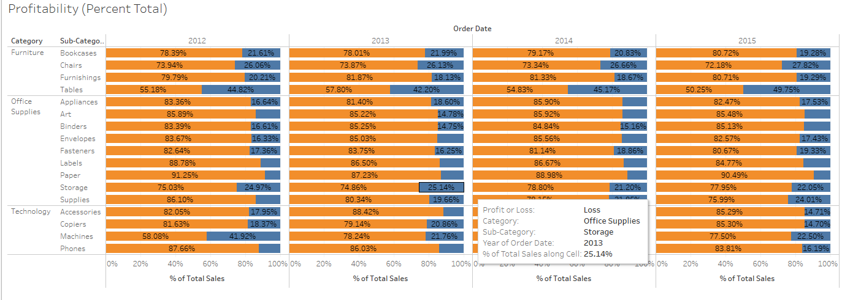

Hint: Use YEAR(ORDER_DATE)

# Exercise 8: Comparing Values

## Task 1: Comparing Values

1. Open the workbook ‘BeyBasic8.twbx’.
2. Create the following calculated fields ‘2012’ and ‘2013’

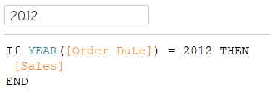

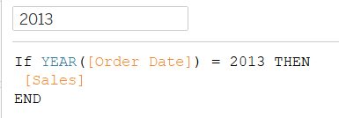

Hint: There is an easier way of creating the ‘2013’ calculated field

Right Click on the ‘2012 and select ‘Duplicate’ from the menu. After the field is created, rename it to ‘2013’ and change the condition to as shown in the above ‘2013’ calculated field

1. Drag the ‘2012’ calculated field to the Row
2. Drag the ‘2013’ calculated field in the same axis as shown:

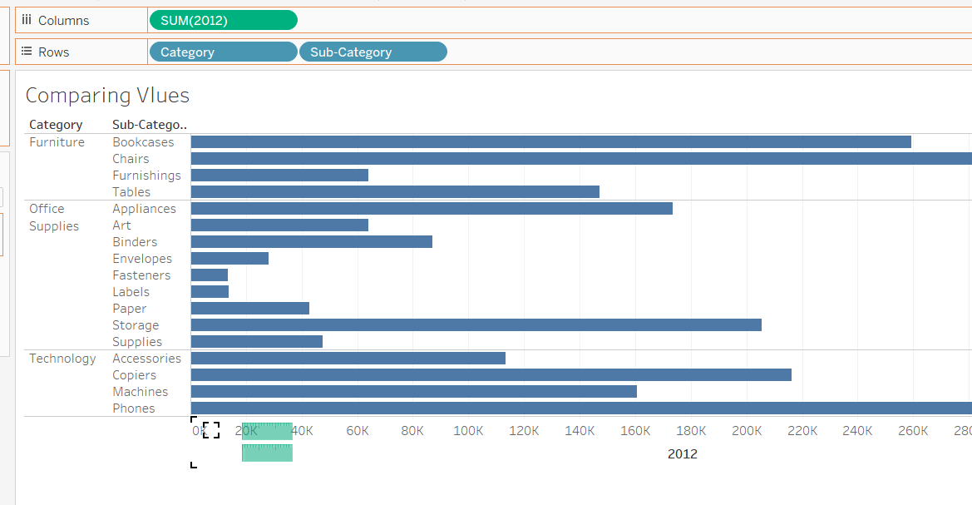

‘2013’

‘

‘

1. You have the following results:

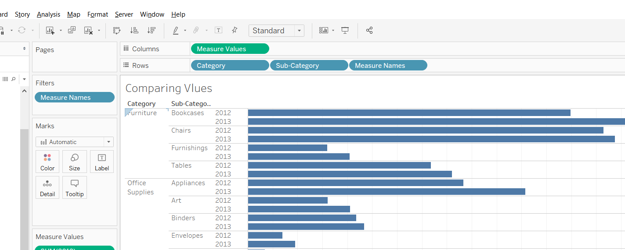

1. Drag the ‘Measure Names’ from the Rows to the ‘Color’ in the Marks panel
2. From the Dimension Panel, drag ‘Measure Name’ in the ‘Size’ in the Marks panel

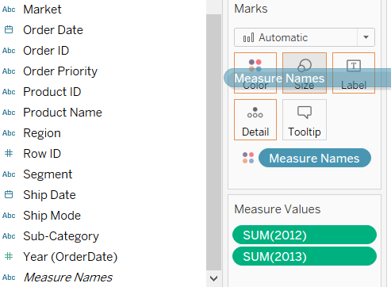

1. After dragging the ‘Measure Names’ into the Size Panel, you will get this screen

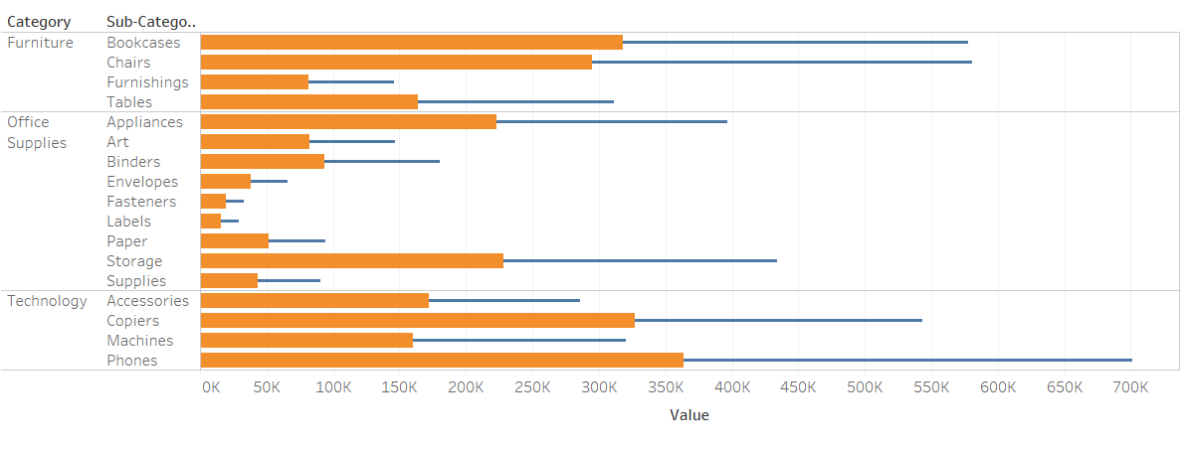

1. Click on the ‘Analysis’ at the top menu, select the ‘Off’ option.

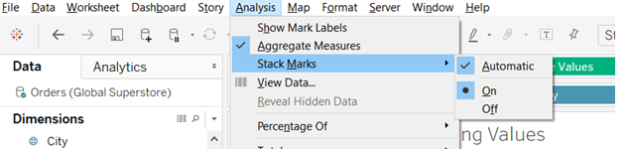

1. This will be the result:

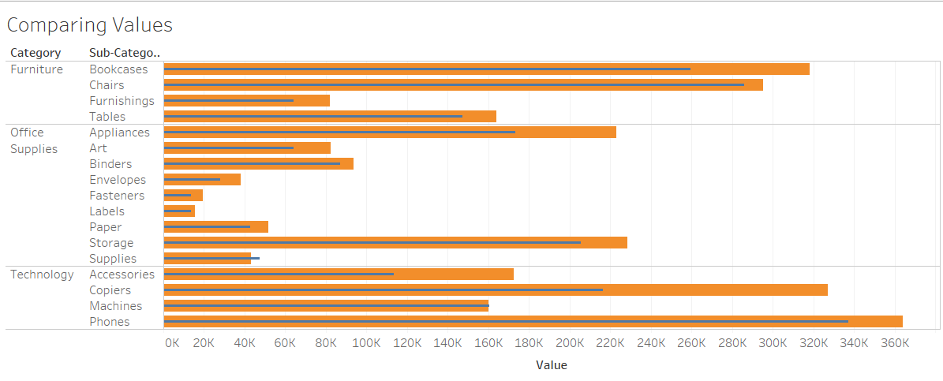

This task allow you to make a comparison of performance between two period of time.

## Task 2: Comparing Performance

1. Open the workbook ‘BeyBasicEx8T2.tbwx’
2. Go to the ‘StateTourismNo’ data source and drag the ‘TouristNo’ measure into columns

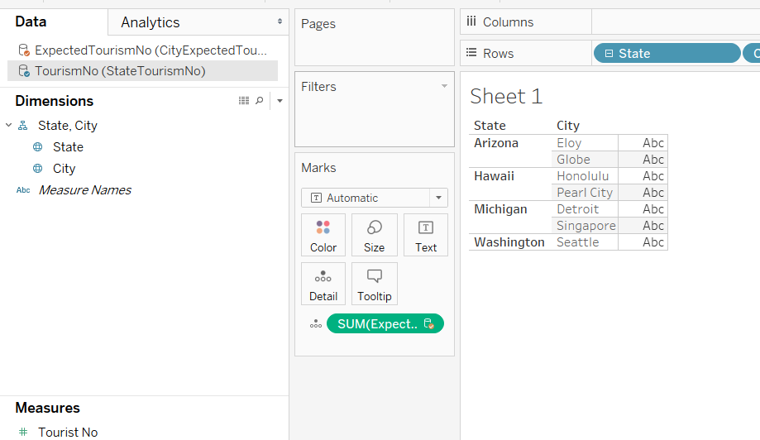

1. Now go to the ‘CityExpectedTourism2 and drag ‘Expected Tourism No’ into the Size in the Marks Panel

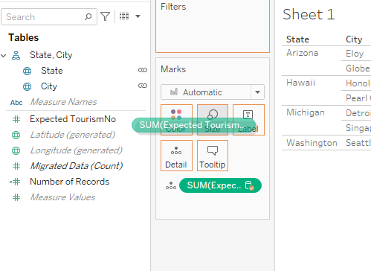

1. From the Show Me menu, select ‘bullet graphs’.

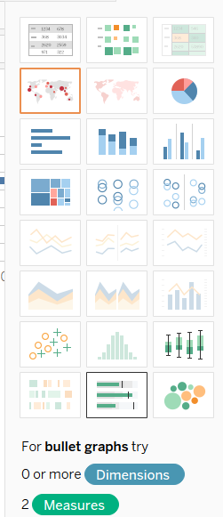

1. This is the result:

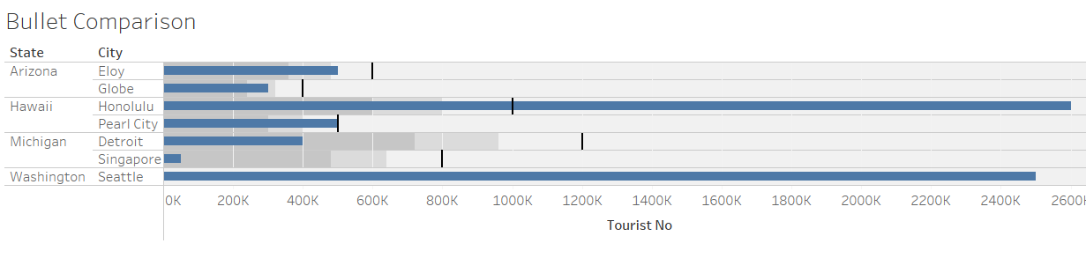

# Exercise 9: Viewing Distribution

## Task 1: Creating Bins (I)

Creating bins provides a systemic data range that helps users to organize information and discover patterns in an efficient manner. Tableau leverage Measured Fields to create numeric bin for data analysis.

1. Open workbook ‘BeyBasicEx9.tbwx’
2. Go to the worksheet ‘Breakdown By Score’
3. Drag the ‘Score’ field into Rows as shown:

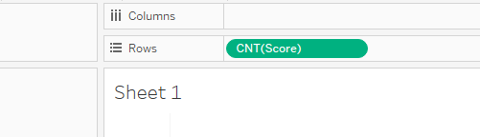

1. From the ‘Show Me Menu’ , select the ‘Histogram’ icon as shown:

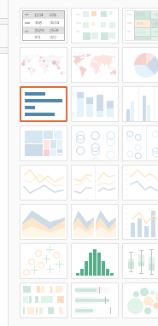

1. You will get the following histogram:

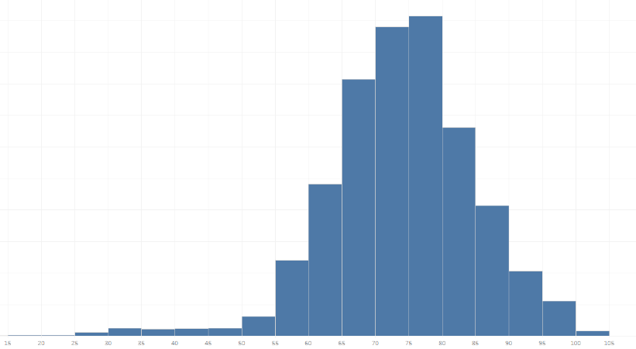

1. Click on the down arrow next to ‘Score(Bin)’ field to edit size of the bin as shown:

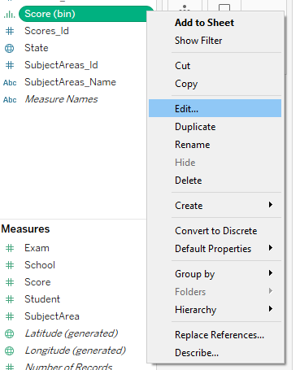

1. Change the Size of bins to ‘5’.

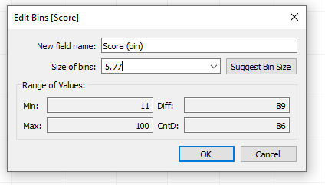

This task is to resize the bin accordingly, basically the range of values that you like to view.

## Task 2: Creating Bin (II)

Note: This task is like Task 1 except you are creating the bin directly from the measure.

1. Create a new worksheet called ‘Breakdown by Score (Custom)’
2. Click on the down arrow next to the ‘Score’ fields from measures panel and select the following option:

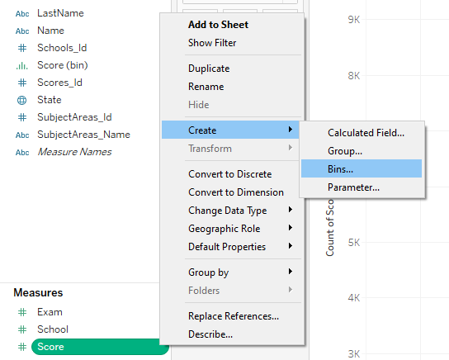

1. In the pop out menu, type in the following:

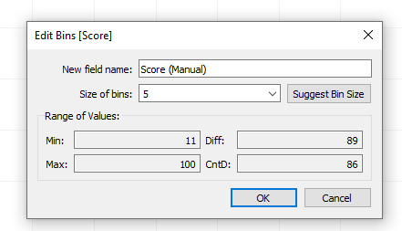

1. Drag the following fields in the respective columns and rows as shown:

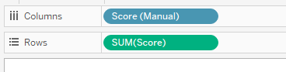

This will create a similar graph that was done in Task 1

## Task 3: Box and Whiskers

1. Create a new worksheet called ‘Analysis of Score By State and Subject’
2. Drag the following fields in the respective columns, rows and Detail in the Marks panel

Do Keep Things simple : (follow this sequence)

1. Drag either ‘SubjectAreas Name’ or ‘Score’ field into the columns and Rows first.
2. Change Sum(Score) to Avg(Score).
3. Drag the ‘State’ field into the ‘Detail’ in Marks Panel

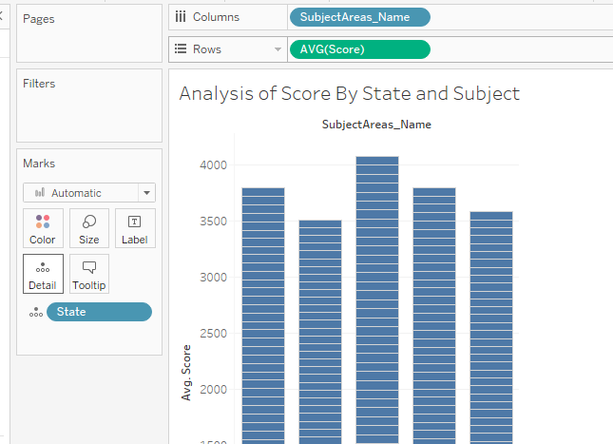

You should this graph

1. From the ‘Show Me Menu’, select the ‘Box and Whisker’ graph:

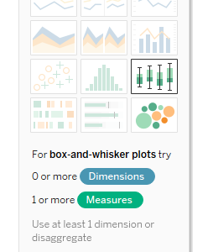

1. This will give you the following Box and Whisker plot:

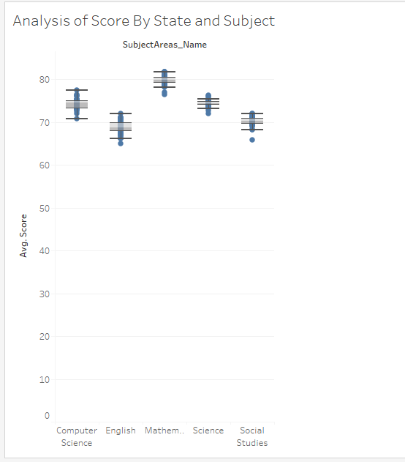

# Exercise 10: Trend lines and Forecasting

## Task 1: Trend Lines

1. Open the workbook ‘BeyBasicEx10.tbwx’.
2. In the ‘Trend’ worksheet, you will observe a Total Profit vs Total Sales. You need to disaggregate the ‘Sales’ and ‘Profit’ to see the individual transactions.
3. Click on the ‘Analysis’ on the menu and remove the tick next to aggregation

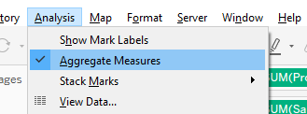

1. The resulting diagram shows all the transactions (sales and profit)

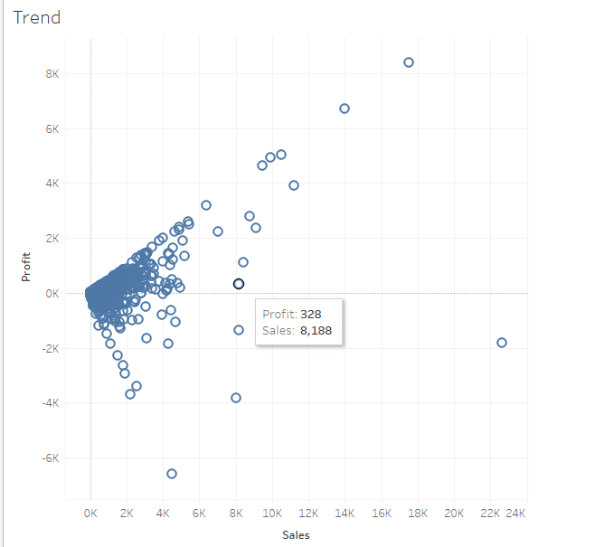

1. Drag the following fields into the respective rows and columns:

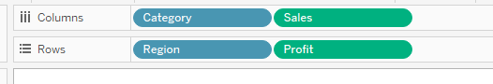

1. You should see the trend based on category and region

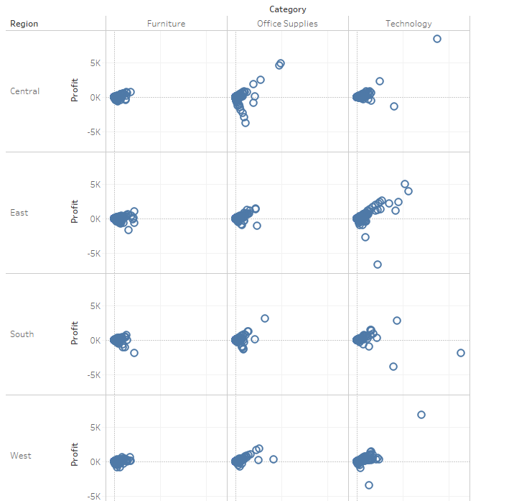

1. Go to the ‘Analytics’ tab

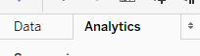

1. Select the ‘Trend Line’, hold the LEFT mouse button and drag into the Linear
2. 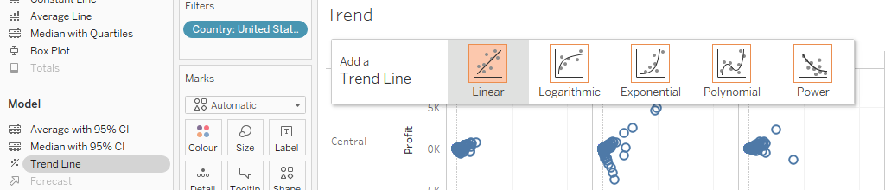

Select, hold LEFT mouse button and drag

1. When you mouse over the data point or trend line, a dialog box will show you information about the data point or the trend line

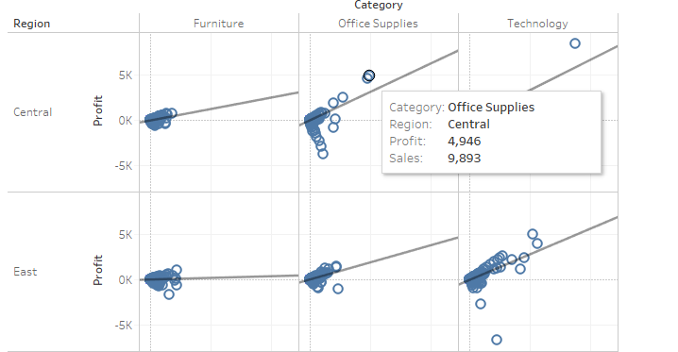

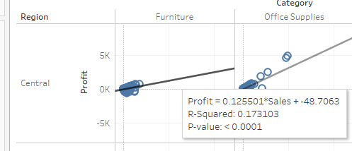

1. Go to the worksheet menu, select ‘Show View Toolbar’ and choose ‘Show on Hover’ option

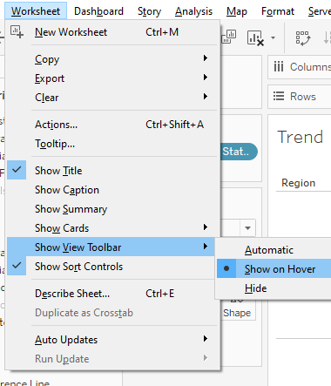

1. When you hover the view, you are able to make use of this set of tools to create new trend line for viewing.

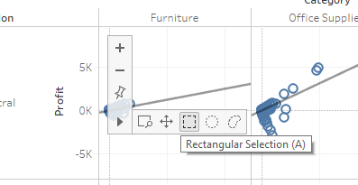

1. For example, when you click and drag over a set of data point, you will see a new temporary trend line drawn:

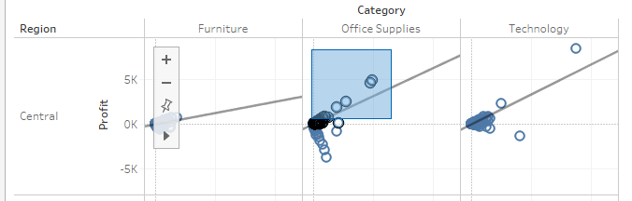

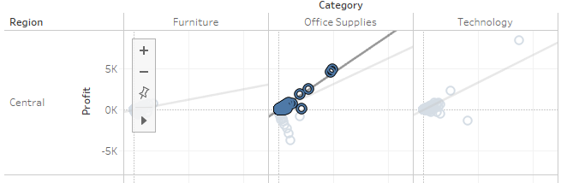

## Task 2: Forecasting

1. Create a worksheet called ‘Forecasting of Sales’
2. Drag the following fields into the respective rows and columns:

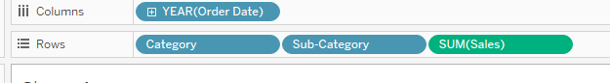

1. For the ‘Order Date’ field click on the down arrow and from the drop down list, select ‘Month’ as shown:

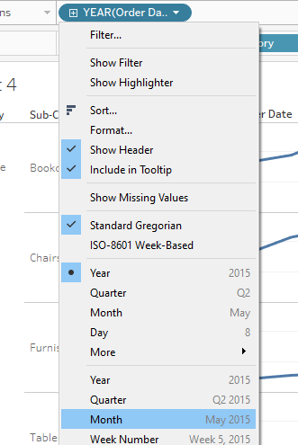

1. Go to the ‘Analytics’ tab



1. Select ‘Forecast’, hold the LEFT mouse button and drag it into the ‘Forecast’

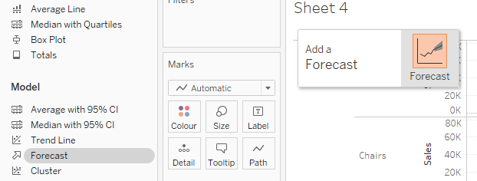

Select, hold LEFT mouse button and drag

1. You will get the following results:

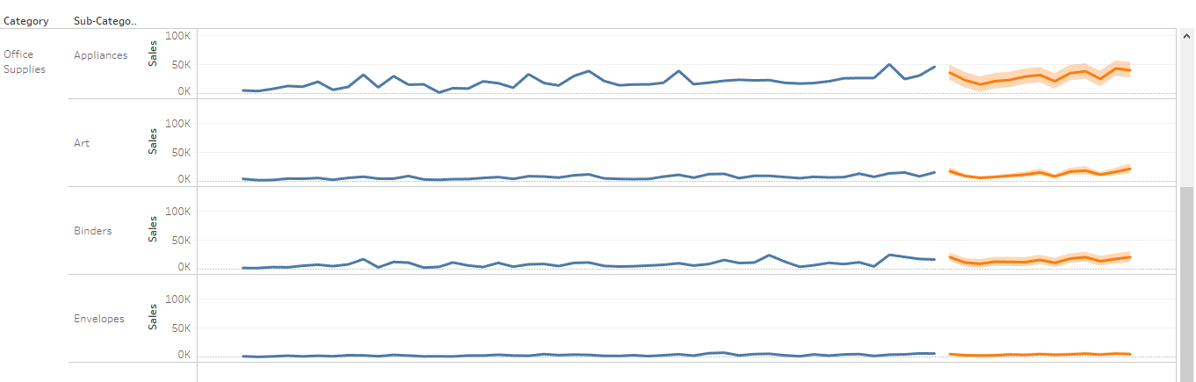

Note: Colors may vary.

1. You may like to forecast the sales for the next 3 years. RIGHT Click any of the forecast line and select the following:

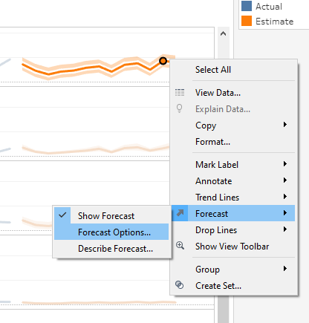

1. When you click on the ‘Forecast option’, it will display the following dialog box:

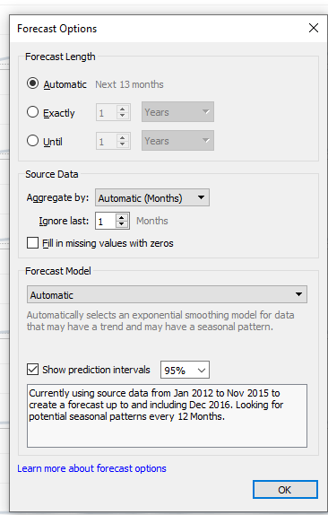

1. Change the ‘Forecast Length’ to Exactly 3 years and click ‘OK’
2. You will see the sales forecast for the next 3 years.
3. For visualization purpose, you may like to select ‘Sales’ measures and drag to the Label in the Marks panel

# Appendix: Solutions to Questions/Tasks in Exercises

## Exercise 2 Task 1

Step 10. The value for ‘Expected Tourism No’ is incorrect. As the tables are joined, each record in the ‘StateTourismNo’ are associated with the ‘Estimated Tourist No’ from ‘CityEstimatedTourism’ table. Hence there is a duplicate computation of the ‘Estimated Tourist No’.

## Exercise 2 Task 2

Step 16: The value for ‘Expected Tourism No’ is correct. As the tables are blended together, there is no data duplicated.

## Exercise 3 Task 2

Step 15: Difference between the data output

For Task 1, data columns are added at row level as shown:

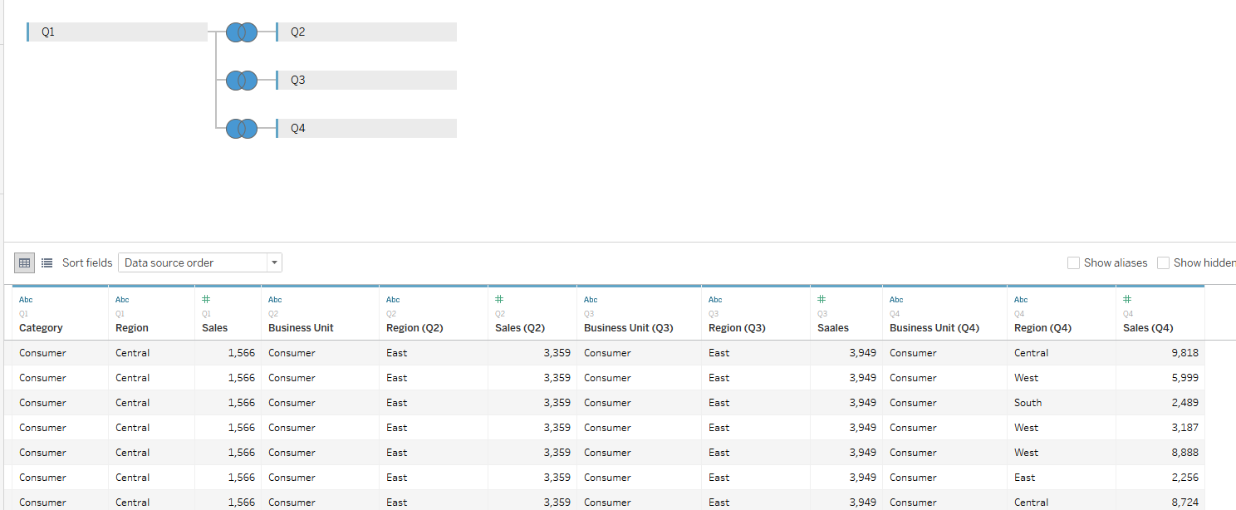

For Task 2, each rows of data from the different data source is appended at the end. It will show you a list of records:

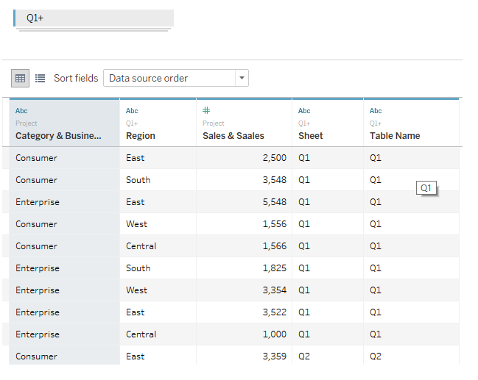

Data from ‘Q2’

Step 16:

In task 2, data can be merged together for better and easier analysis. For example, comparing the performance of the sales over the different quarter.

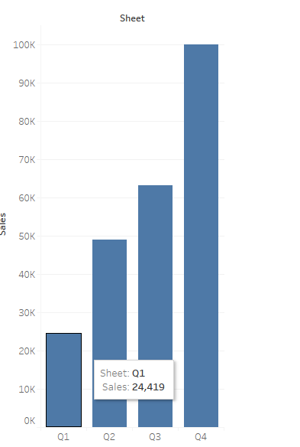

## Exercise 5 Task 4b

1. Select the required fields and drag into the respective column and row

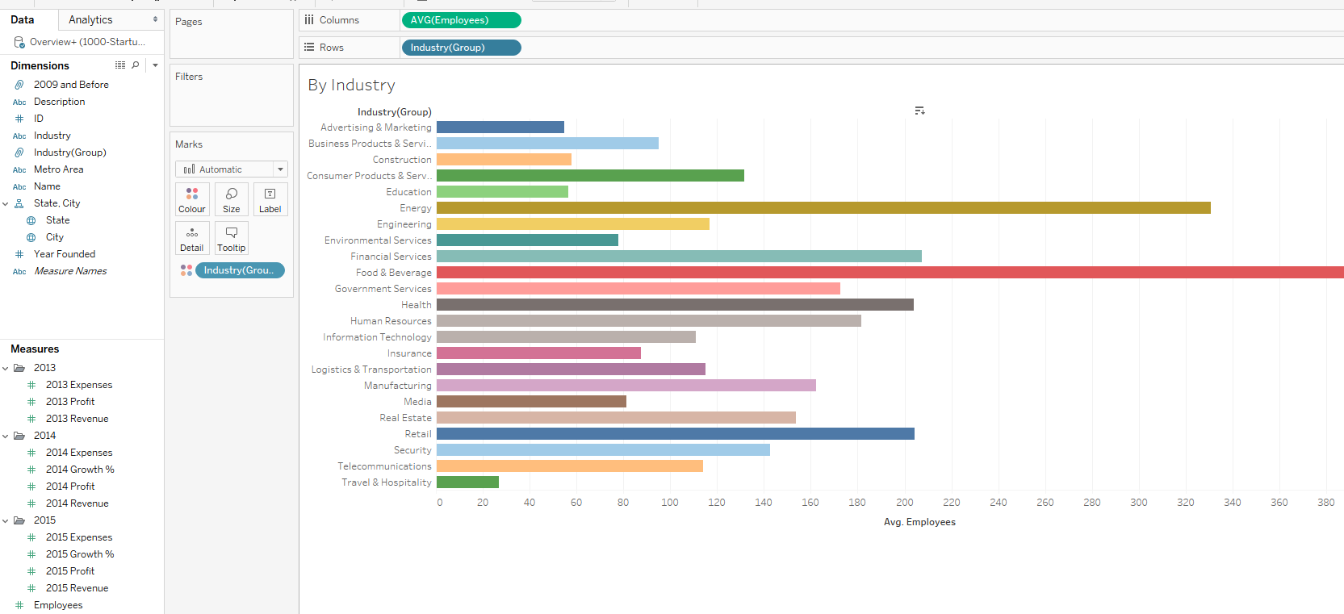

1. Change the aggregated SUM function to AVG
2. Click on the Sort icon



## Exercise 5 Task 5a

Step 12:

The disadvantage of using static set is that when there are new data available, it may not capture the changes. In this task, if there are new growth data available, there may be new Top Growth companies.

## Exercise 8: Task 2

Step 10: Drag the order date into the Column as shown:

